**Section 1:**

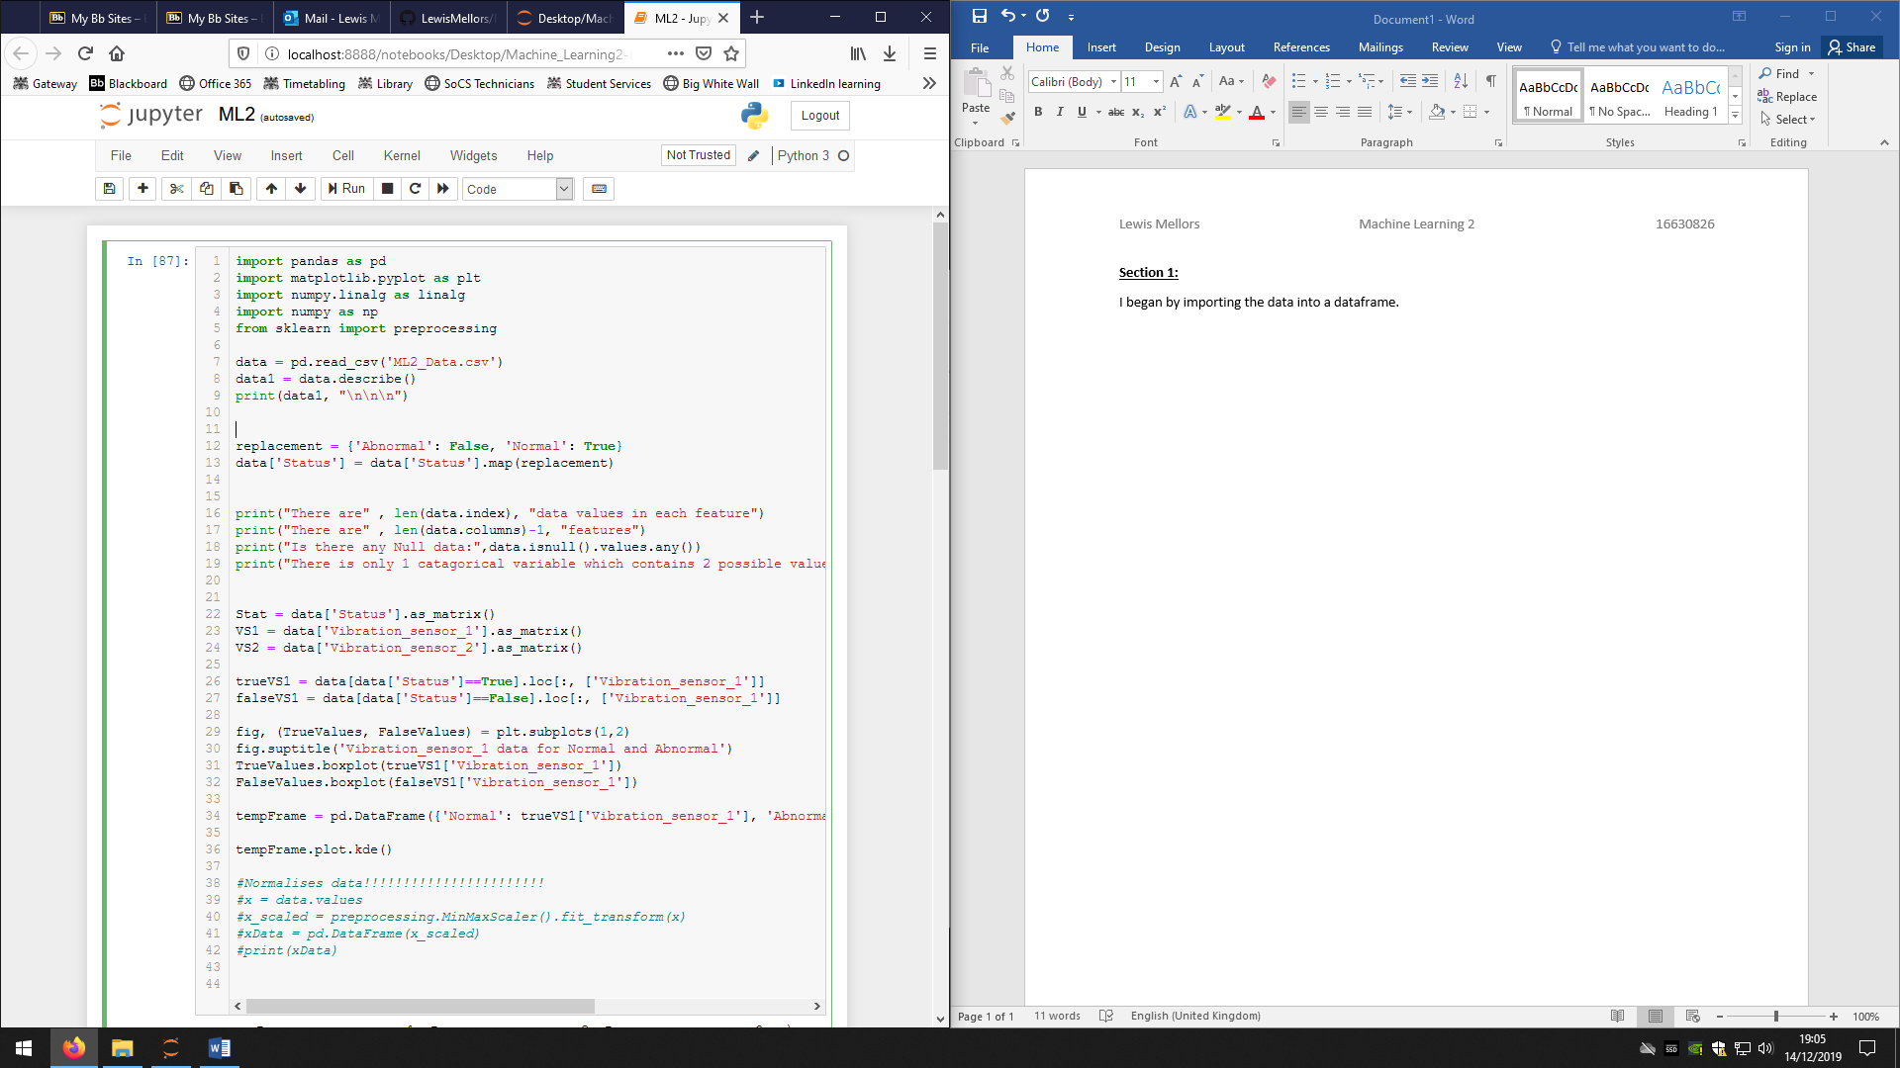I began by importing the modules that I would use, these included modules that would assist in analysing the data as well as plotting the graphs needed for this assignment.

*Figure (1)*

Next I imported data into a data into a data frame and used the *describe()* command to get all the relevant statistical information on each of the features.

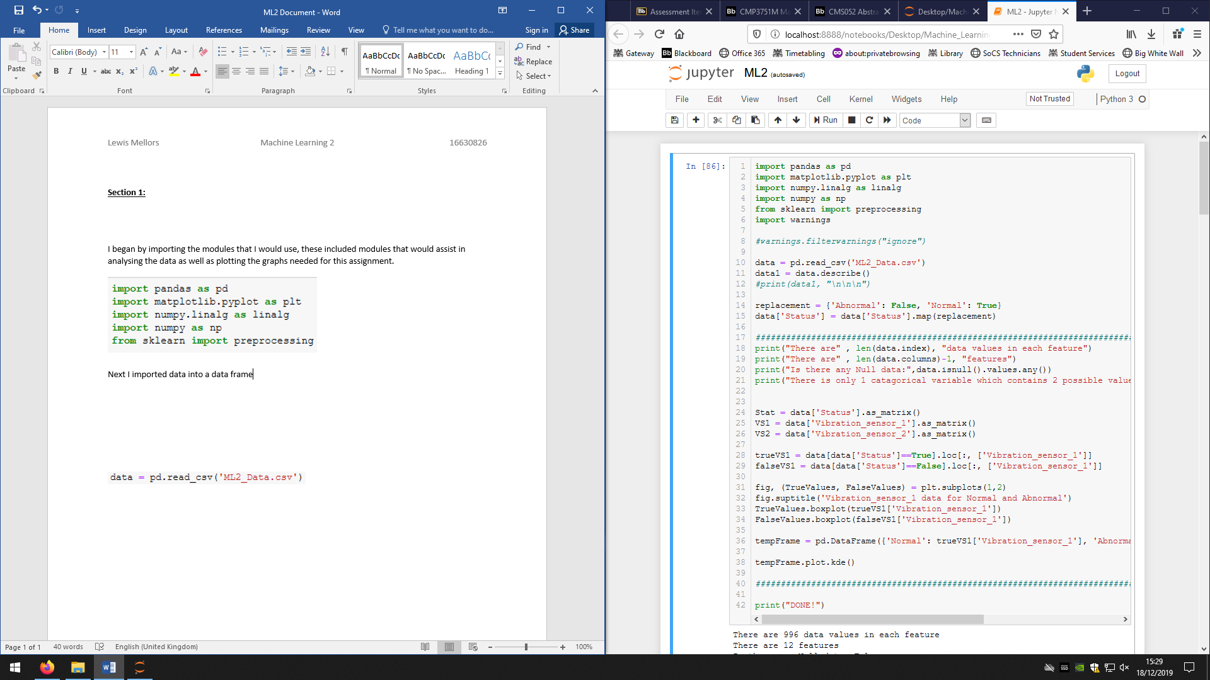

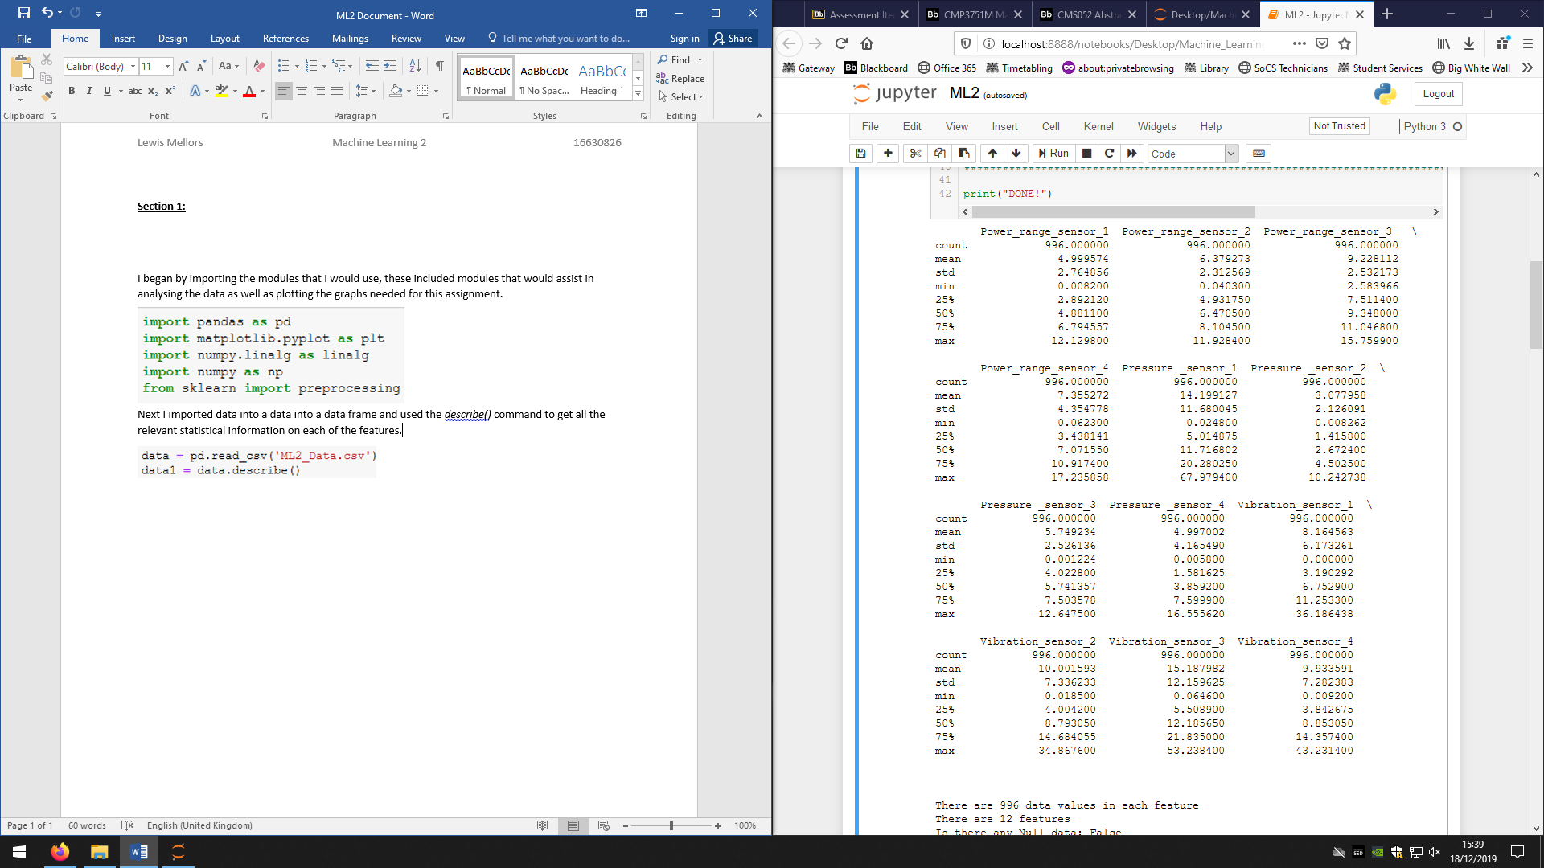*Figure (2)*

*Figure (3)*

As you can see, the Figure(3) shows the count, standard deviation, min/max values as well as the median(represented by the 50%), and the upper and lower quartile (represented as 25% and 75% respectively). This is what the *describe()* function has done in order to get these values:

For the mean, the values of all the data in a feature are added up and then divided by the total number of values in that feature. The formula for this is: $an= \frac{\sum{X}}{N}$. What this figure shows is the average value of all the data, this value can be drastically altered by any outlying data (data that is outside the trend of the data by a drastic amount) meaning the mean does not always show the average of the data trend.

For the standard deviation, all the values are compared to the mean to find how far they stray from the mean, these numbers are then squared to make them all positive and summed together and divided by the number of values in the feature, and finally they are square rooted. The formula is: $andard Deveation= \sqrt{\frac{\sum{{(X-\overline{X})}^{2} }}{N}}$. What standard deviation shows us is the average stray the data values have from the mean, showing the spread around the mean and is good for comparing data sets which have the same mean but have different ranges for their data. This can also be drastically changed by an extreme outlier, and so it is best to determine outliers before doing the mean and standard deviation and discuss whether they should be excluded or not.

The min and max values just show the smallest and largest values in the set and can be used to determine the range.

The median is the value at the middle of the data set, on its own it does not say much about the data but when other statistics have been found it can be used to show skew in the data. On its own it is good as it itself is not affected by extreme values and so will always show correctly. This is done easily by finding the value and the middle index. The upper and lower quartiles are similar to the median but they are finding the values at the 25% and 75% mark of the data. This is again done very simply by finding the data value at the first and last quarter index.

This can be done without using *describe()* by using the numpy library giving us:

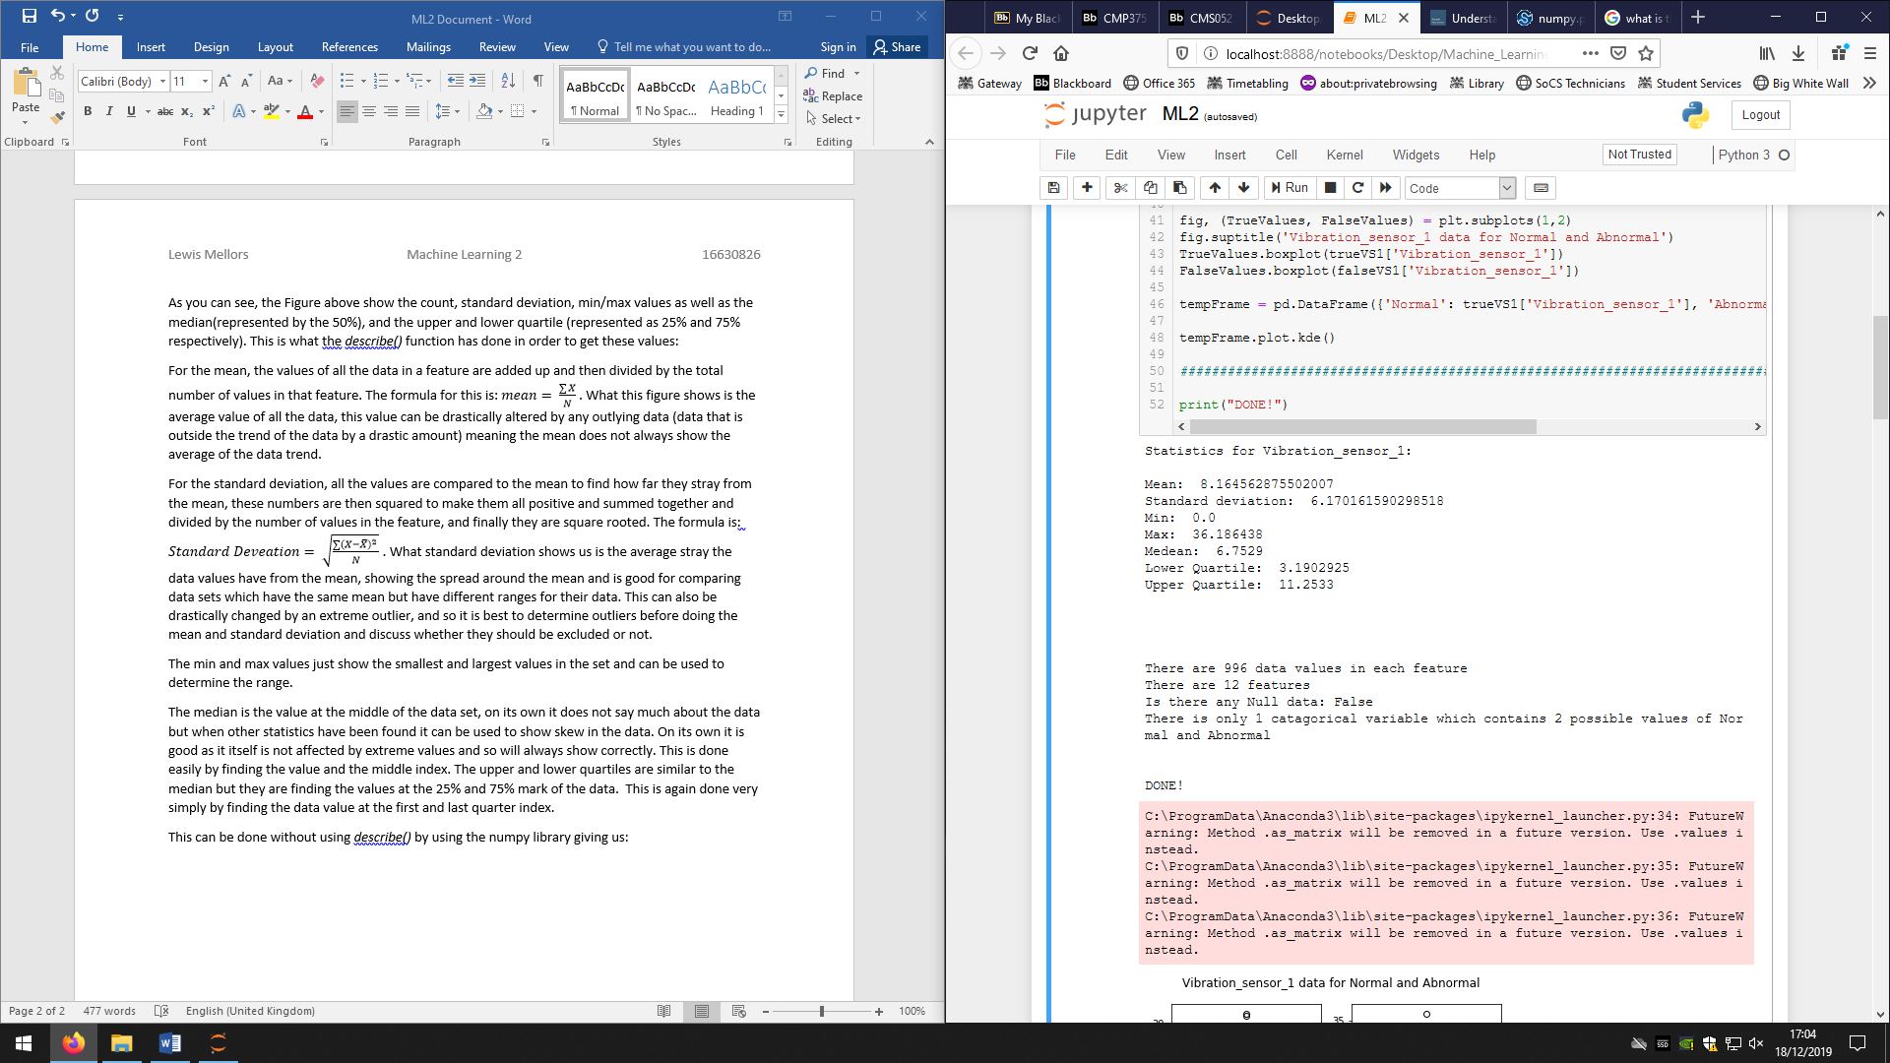*Figure (4)*

Figure (4) shows the printed statistical values of the feature *Vibration sensor 1* using the numpy library commands. As you can see, they are the same as what is produced from the *describe()* command.

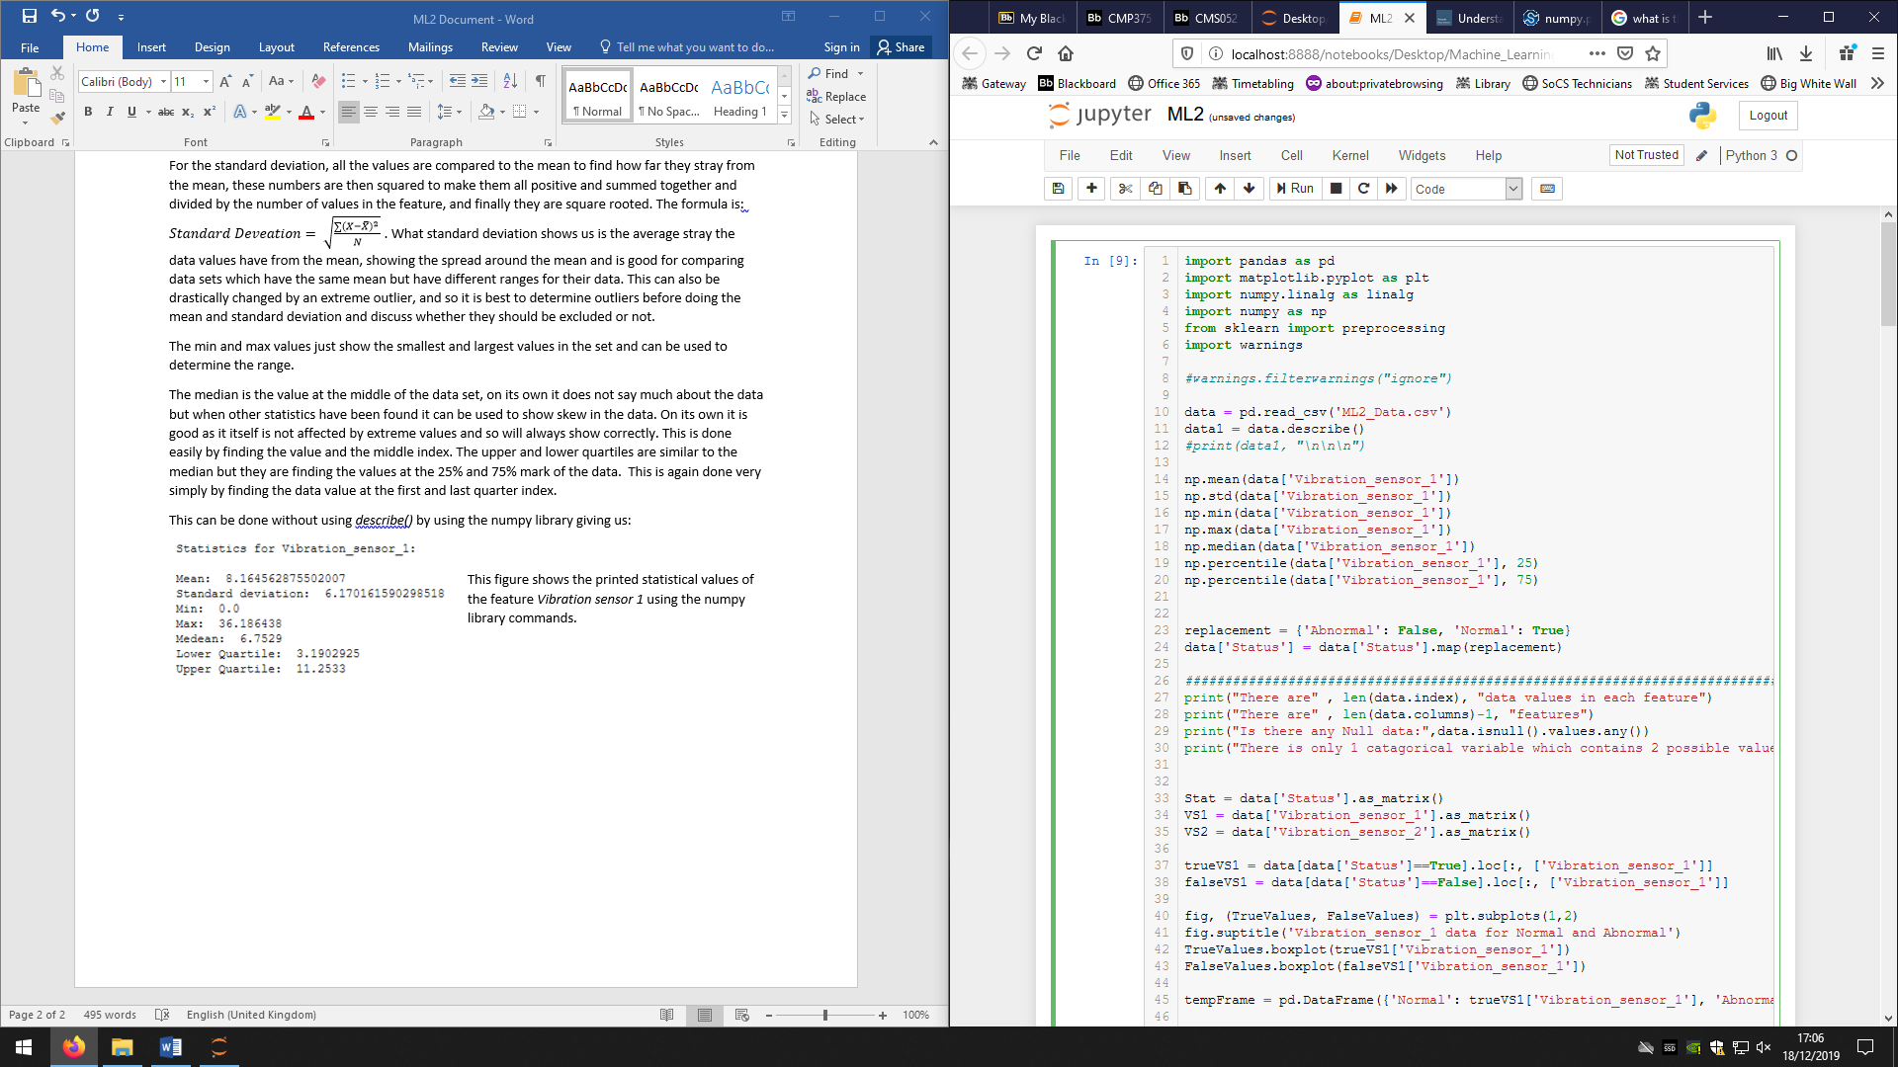

The figure to the left (5) shows the commands used to create the values in Figure (4), np is the shorthand for accessing the numpy library. Data[‘Vibration_sensor_1’] is calling just the one column from my dataset.

*Figure (5)*

The data set that we were given consisted of 996 data entries that contained 13 features each. These being Power_range_sensor_1 to 4, Pressure_sensor_1 to 4, Vibration_sensor_1 to 4, and finally a *State* feature that said whether the reactor with those specific values was running normally or abnormally. This can be proven with the print:

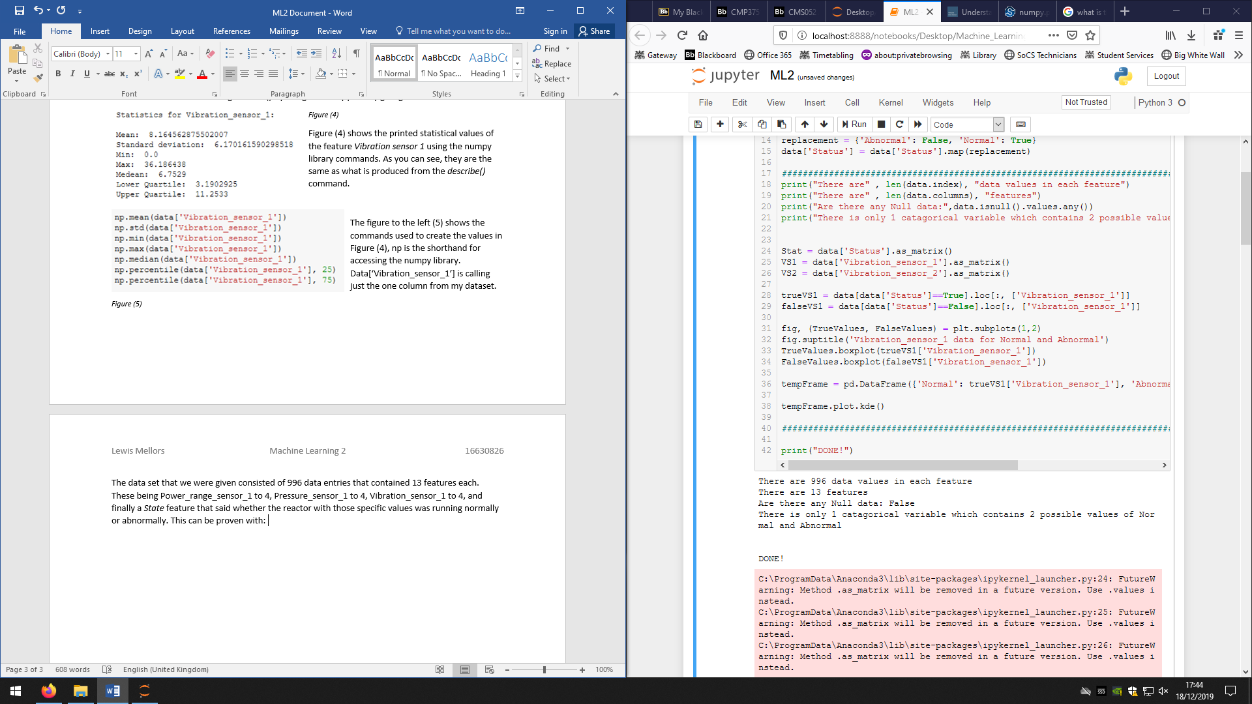*Figure (6)*



*Figure (7)*

Figure (6) shows the print of the code in Figure (7) which proves the size and shape of the data. d*ata.index* is just an array created containing the index values meaning the number of rows, and *data.columns* creates an array of the columns, then command *len()* gives the length of the arrays.

To check if there were any null or missing values from the data set I used a pandas command called *isnull()*:

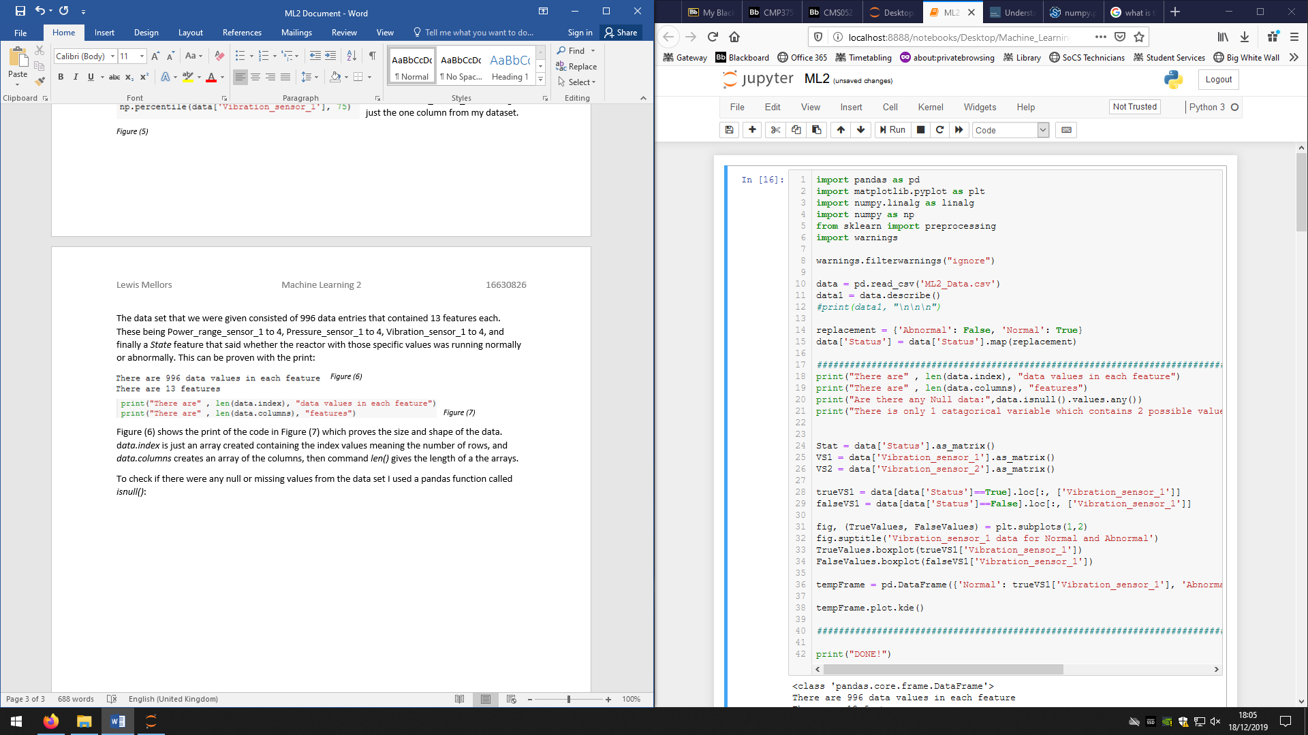*Figure (8)*

Figure (8) shows a print code that uses this command, the add-on after the command tells the command to check all the data values in the data frame. This will produce a True if there are any missing values and a False if the data set is complete. This code produces:

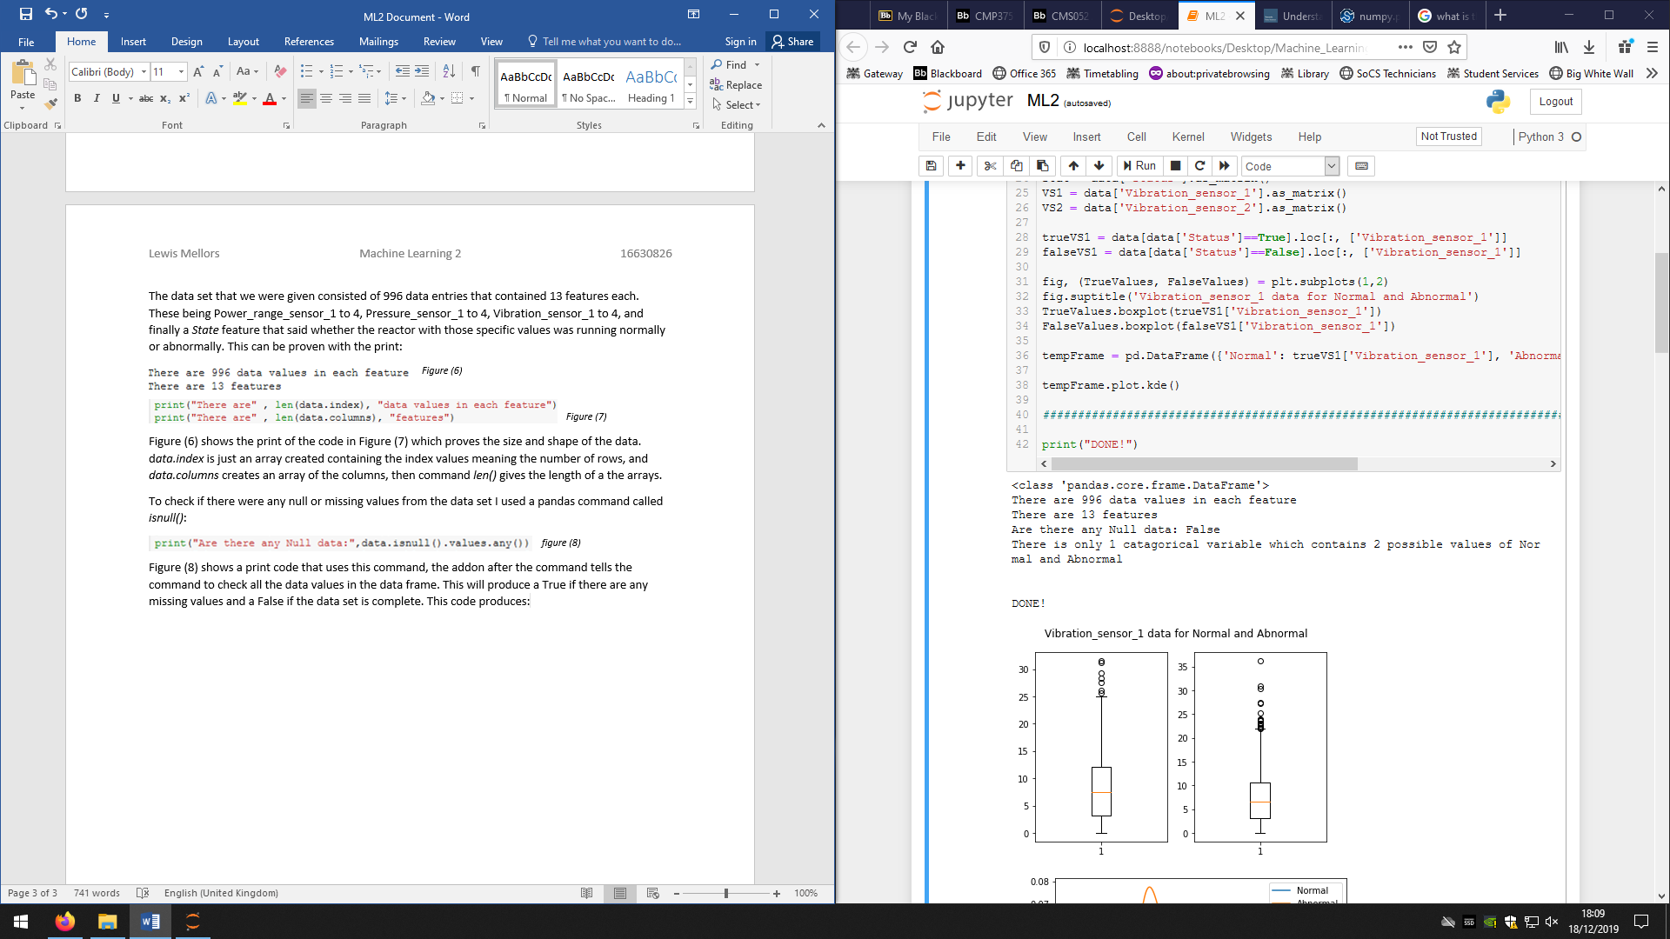*Figure (9)*

Figure (9) shows the print that is created from the code in Figure (8) and shows that the data set is complete and that there are no missing values in any features.

Categorical data is data that has a limited or set number of possible answers or groups, for example, race, sex, and age group are categorical data sets. For our data set there is only one feature that is categorical which is the *Status* feature. There are only 2 possible answers for this feature which are normal and abnormal.

Normalising data is the method of converting your numerical data into a range of between 0 and 1 respective to the range of the data. We do this because the features have different ranges as the features with the higher values will influence the data more than a features with smaller values, normalisation makes each feature equally influential. I have done this with the following code using sklearns preprocessing library:

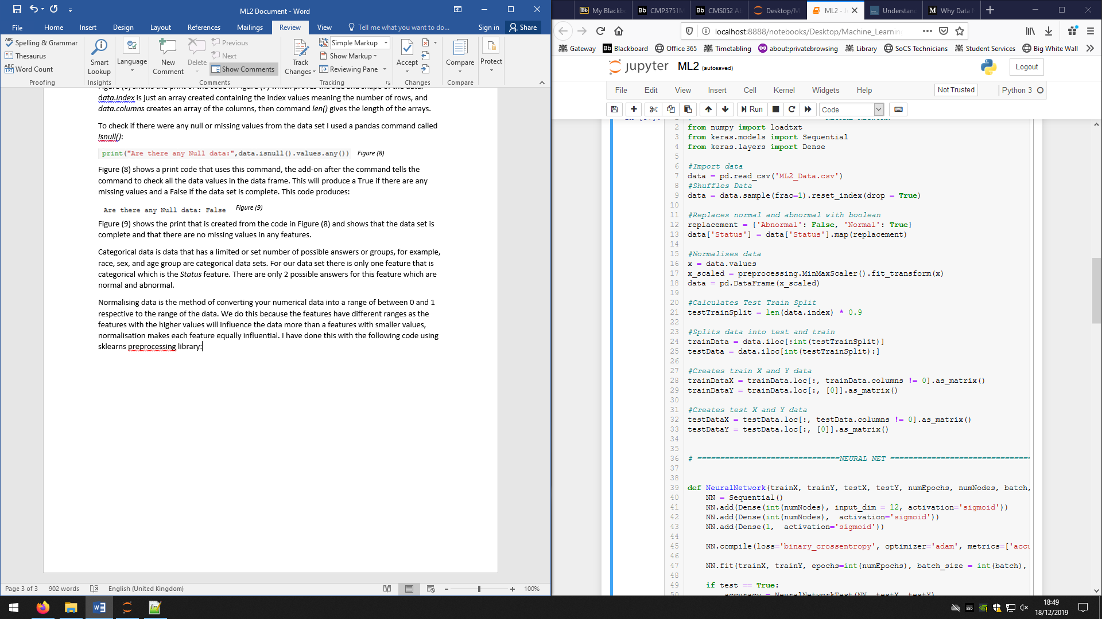

*Figure (10)*

I then used the data provided to plot 2 types of graphs, the first being boxplots and the second being a density graph. I plotted 2 boxplots for feature *Vibration_sensor_1,* one with the normal data and one with the abnormal data for the feature. I first had to create 2 data frames from the full data set, they would contain the normal and abnormal data:

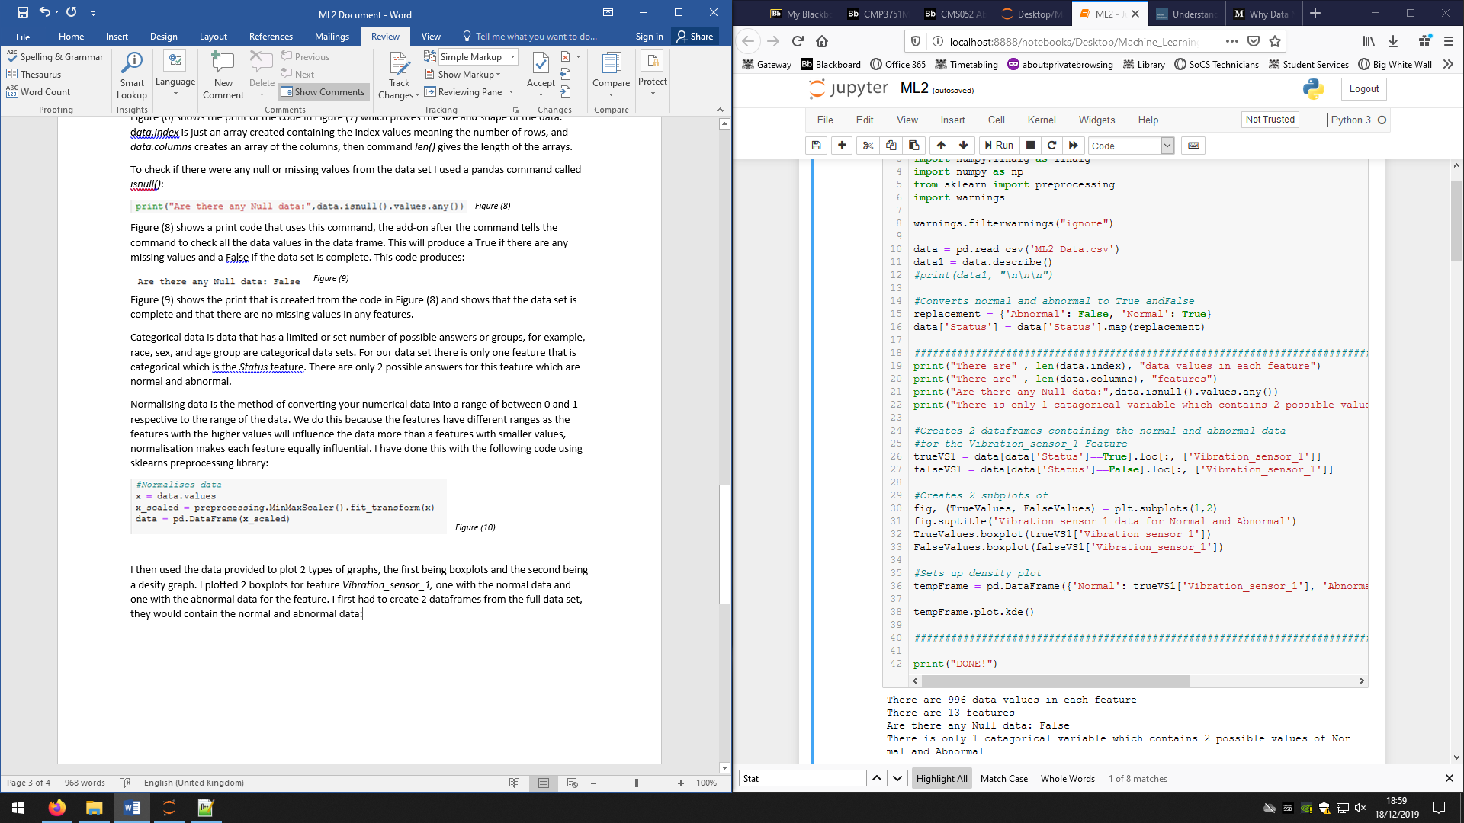

*Figure (11)*

I then created 2 subplots and used them to create 2 boxplots for the normal and abnormal data:

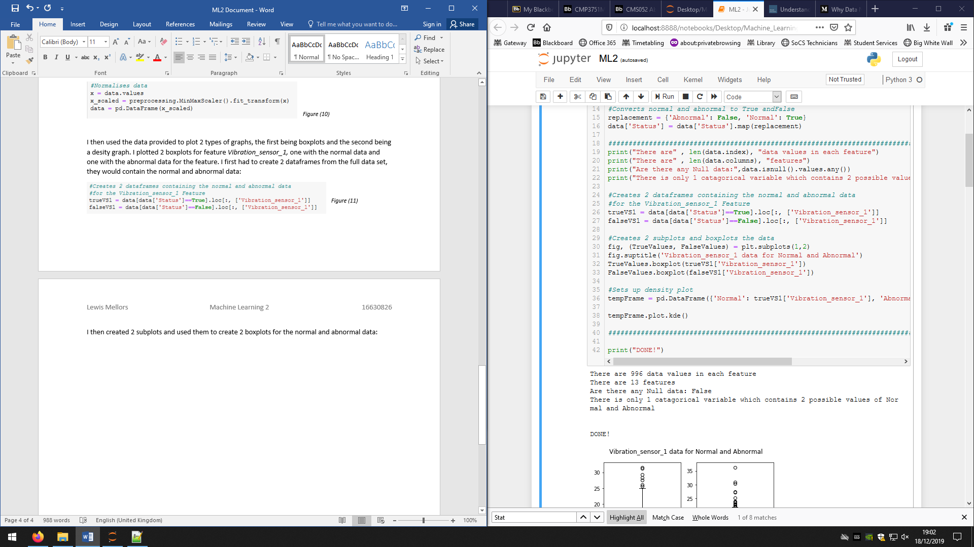

*Figure (12)*

This code then produced the following graphs:

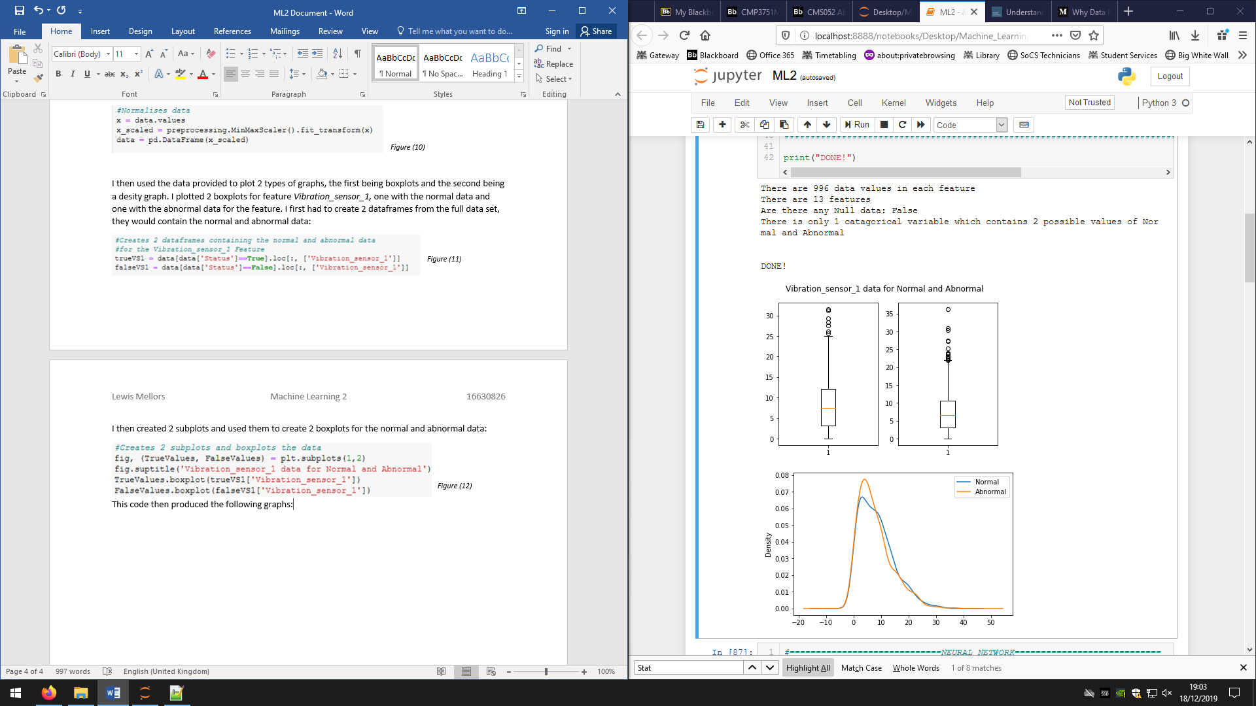*Figure (13)*

Figure (13) shows the boxplots of the normal (left) and abnormal (right) data for *Vibration_sensor_1* feature.

These graphs show that the range of the normal data is higher than the abnormal data as well as the interquartile range (space between upper and lower quartile) of the normal is greater than the abnormal showing the data is more spread out for the normal. This indicates there are more values that can produce the normal status than there are that can produce the abnormal status. Both plots are skewed and so the distribution of values are greater at the lower end. These graphs do show the outliers in the data, it shows that the abnormal data has more outliers than the normal data.

The second graph was a density plot for the *Vibration_sensor_2*: 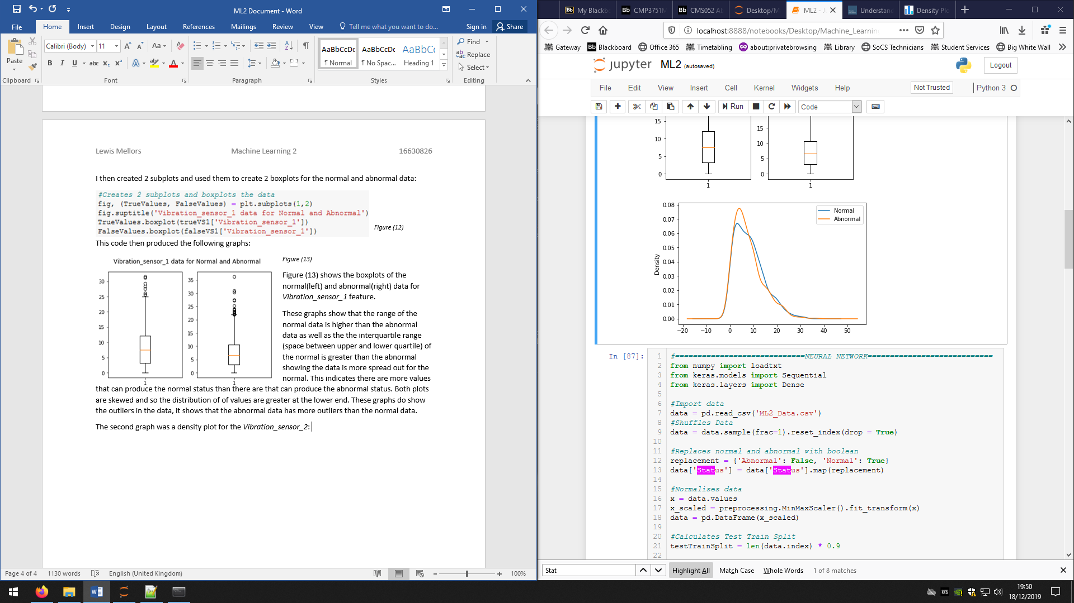

*Figure (14)*

Figure (14) shows the density plot for the normal and abnormal data. This graph confirms the higher spread of data for the normal data set as the peak in the graph is lower and the width between the peaks is wider. However, this plot does show that the range of the abnormal is larger than the normal as the abnormal graph is still above 0 later on the X axis. This graph does show some outliers as where the line is no longer smooth and ‘wobbles’ is a sign of data that does not fit the trend. This is because the kernel density estimation creates a linear regression line and that can be effected by outliers which creates a tremor in the line.

**Section 2**

The data set that the reactor provides is a large dataset, it contains 996 sets of data each with 13 values, and this means the models should be able to handle this large amount of data reliably. If it could not handle large data then the data set would have to be split up into smaller sets which could decrease the accuracy of the model overall or give false positives as the model might work with small sets but would not work with large sets. This is a similar principal if you were to shrink the data by splitting up the features, the model might be accurate with few features but the different models created by the different sections could give different results. A requirement of the model is that it must run quickly when predicting the outcome of new data as the environment it is going to be used in is a very delicate one. Any abnormal scenarios must be acted upon quickly or else a catastrophe could occur causing loss of life and huge environmental damage. This also leads onto the major point that the model needs to be accurate in this situation, as a false normal means no action is taken on a dangerous situation that is going to get worse and again could cause a huge catastrophe.

The intern has split the data into train, validation, and test, it is good to understand the differences between them and know why some algorithms do not use them all. The training data is used for exactly what it says, to train a model. The feature data is inputted into the model and the results are compared to the actual results of the data, the variables of the model are then changed based on the accuracy of the answer comparison. This is done for a set amount of time and hopefully the model learns and becomes more accurate in its predictions. Validation data is similar to test data but has a clear difference. Validation data is used to test the model with a new set of data periodically while training the model, this is to get an estimation of the models skill at that stage of the training. This is something that you can use to see if the model is improving through the training. Finally, test data is used when the model has completed its training fully and now needs to be tested on a fresh set of data it has never seen before. This gives you the final accuracy of your model.

One of the models the intern tried was KNN or K Nearest Neighbours. This is a classifying model that is simple and easy to create, it is classed as a “Supervised machine learning algorithm” meaning it trains itself using data that has the correct answer known already and so can validate and compare answers. This algorithm works by plotting the data on a graph where each axis is a feature of the data, random centroids are created and each point on the graph calculates which centroid it belongs to and joins that group. The centroids are then recalculated by getting the mean position of all points in their groups, the process then repeats until the centroids no longer move when recalculating. This is a good algorithm for datasets that have few features but cannot work with larger number of features such as our data set, this means KNN could not be used for our situation as it could not handle all 12 features. Another problem is that the intern split the data into train, validation, and test but KNN does not use separate data sets and would just use the entire dataset to create itself. KNN would be good when handling our large number of data (996) as it can handle large amount of points well but it could be slow which is not good for us.

Another model the intern made was SVM also known as Support Vector Machine. This method is similar to KNN as it plots the data on a graph with the axis being the features, however, SVM creates a linear separation between the sets of data using hyperplanes. It looks at the positions of the data groups and tries to find an optimal line that would split the data fairly. A positive of SVM is that if the data is 2D and cannot be divided in a linear fashion, then SVM solves this by increasing the dimensions but only if it is possible to add another feature. There are a lot of negatives to SVM though for our situation. Firstly, similar to KNN, SVM cannot work with high amounts of features meaning it could not work with our data set. SVM also is not good at handling a large amount of data and so would be highly inefficient for our 996 sets of data, this would increase the already high time and memory cost of SVM which goes against one of our needs. The SVM can work with the intern’s data splits, unlike KNN. Overall, SVM would not work with our large number of features and would also take too long train but would be good at testing new data quickly.

The final example is Neural Networks (NN), this process is a lot more complicated than the others and will be briefly explained now but full explained in later sections. A brief explanation is that the network is made up of inputs, hidden layers of a certain amount of nodes, and output nodes of a certain amount of nodes based on the desired outcome. The 12 features are sent to each node in the hidden layer, they are multiplied by weights that are different for each feature connection to each node. For example, if you have 5 features and 10 nodes, there would be 50 weights. Each node then adds up all features multiplied by their weights and puts that number into an activation function. The activation function then outputs a singular number which is then sent to the next layer of nodes in the same way as before (all to all). This is done until the final nodes, output nodes, where the final values are compared to the expected outputs, you then square these differences and add them together giving a cost and begins back propagation. The entire aim is to lower this cost, to do this the weights are adapted. For each set of data (1 of the 996) a cost is made and then for each weight for the connection to the previous layer, a change in weight is made that would lower the cost. This is done for the next layer back and so on, until all the weights have a desired change. The network does this for all the sets of data and then gets the average desired change in weights and then applies those desired weights multiplied by a learning rate. This then happens for the number of runs through the data set specified and should lower the cost and therefore increase the accuracy each time. NNs work well with large data sets and depending on the specific parameters of the NN, can train and test very quickly which would be good for us. The neural network can also handle the 12 features we have very easily and could be scaled up if the plant decided to add more features. NNs do have a problem that training the network is very costly for memory and if you have large parameters, it can take a longer time to train, however, it is still relatively short. There is a problem with NNs, which is the accuracy can be less than 100% which could cause severe problems for a nuclear reactor.

All the methods could be split into one of three types; supervised, unsupervised, and reinforcement learning. A supervised method is one that uses data to train itself and then is told how correct it is and uses that to change itself, it is stopped by an iteration limit or when it gets above a certain accuracy. Unsupervised learning is when the model uses the data to predict an outcome but does not get any feedback meaning it does not know if it is right or wrong and why. This means to get a good predictor using these methods, it is by random chance that it is good. Again, these methods end after a number of iterations or when it get a good accuracy. However, if you end it after a number of iterations then the final model could be completely useless. Finally, reinforcement learning is when a model trains on a set of data and is given a score and its aim is to improve that score. However, it does not know what to change to improve the score and so has to change its parameters until it learns what will increase the score. This ends the same as supervised learning.

The intern decided to choose the method that performed the best at 90% accuracy. I both disagree and agree with them. I disagree with them as there is more to choosing a method than just the accuracy, especially in a situation such as this. However, I can agree with them that the accuracy is very important and the method they chose could fit the other requirements perfectly, but I cannot agree with them if they chose the method solely based on the accuracy.

I would chose a method by first setting out my requirements based on the situation. For our situation I would want a model that can handle all 12 features in a single model, I would also want the model to predict the outcomes quickly as every second counts as stated above. I do not mind if the model takes a long time to train as there are other methods already in place to tell if the reactor is normal or not and so there is not a time limit on model creation. I would also want the model to be as accurate as possible as to not cause any faults that have severe consequences. There needs to be a balance between the importances of these requirements as it is unlikely that you will find a model that fits them perfectly and so a compromise needs to be made. Once I have decided my requirements, I would see what type of data I had to input. The data we have contains the known results and so I would not use an unsupervised method as it would be a waste of data, the status, as well as a waste of time as it would take so much longer to create a good model. I would choose a supervised learning method over a reinforced learning one as it would be quicker to improve as we tell it where it went wrong and it knows how to improve, reducing the time to train. Next I would think about what I want for my output from the model. Technically, this is a classification problem and so that would be a clear choice but it can also be solved by regression models, such as ANN. Through this entire process, I would be narrowing down possible methods until I have a final list after these steps. With this final list, I would then research them compared to the requirements I have and then choose the most suited from that.

In conclusion, I would not agree with the intern if they chose it based on just the accuracy as there are many other features that go into choosing the best algorithm and choosing based on just one could jeopardise the entire model.

**Section 3**

For this section we had to create a Neural Network as well as a Random Forest Classifier. I began by preprocessing my data. I first imported the correct modules that I needed for the creation of the Neural Network, for this I used the module *Keras*. Since this is not a base module I had to install it using the Anaconda Prompt, I did the same for a module called Tensorflow which is in order to use Keras. To do this I used the commands:

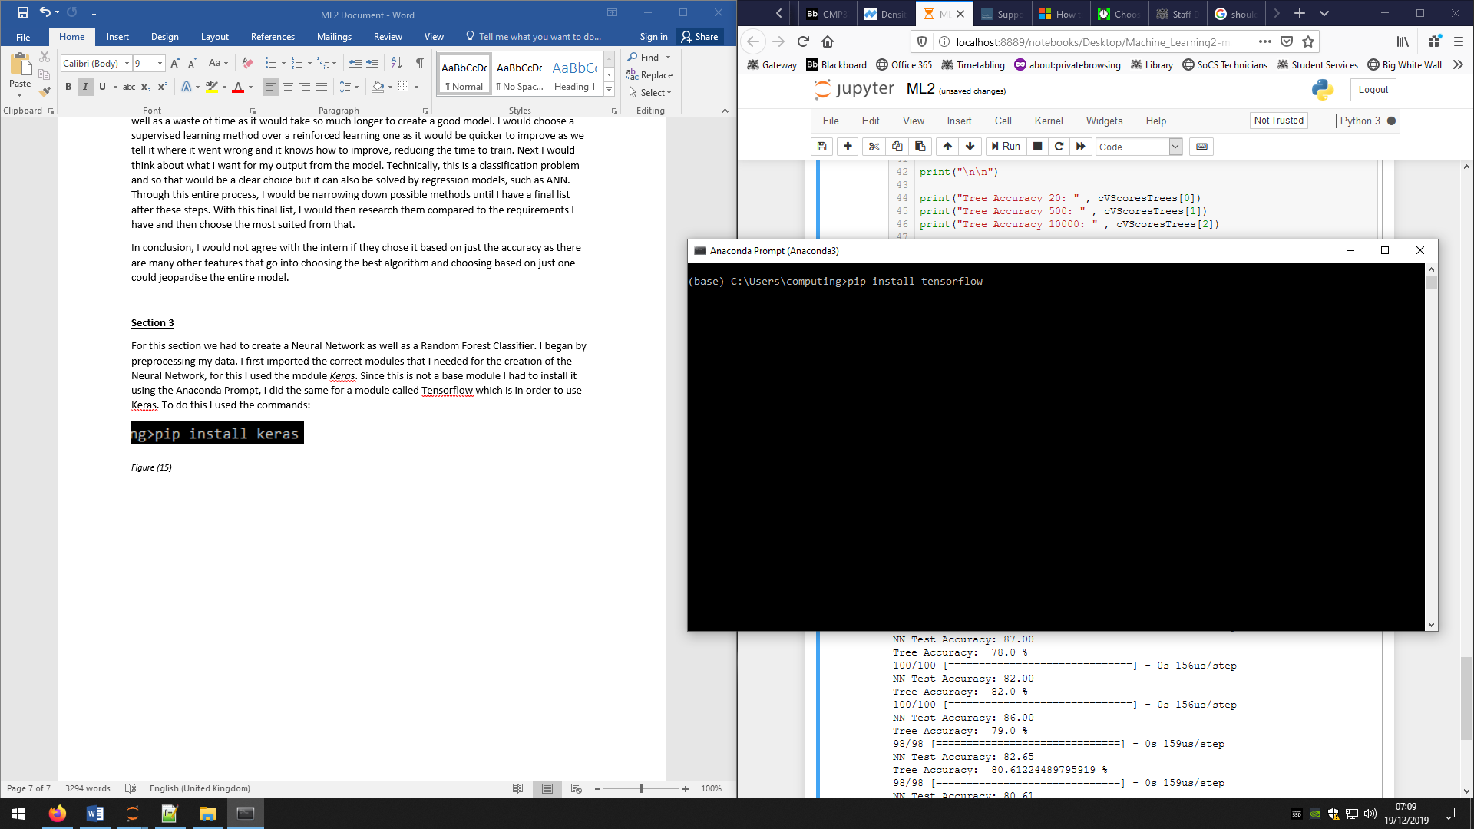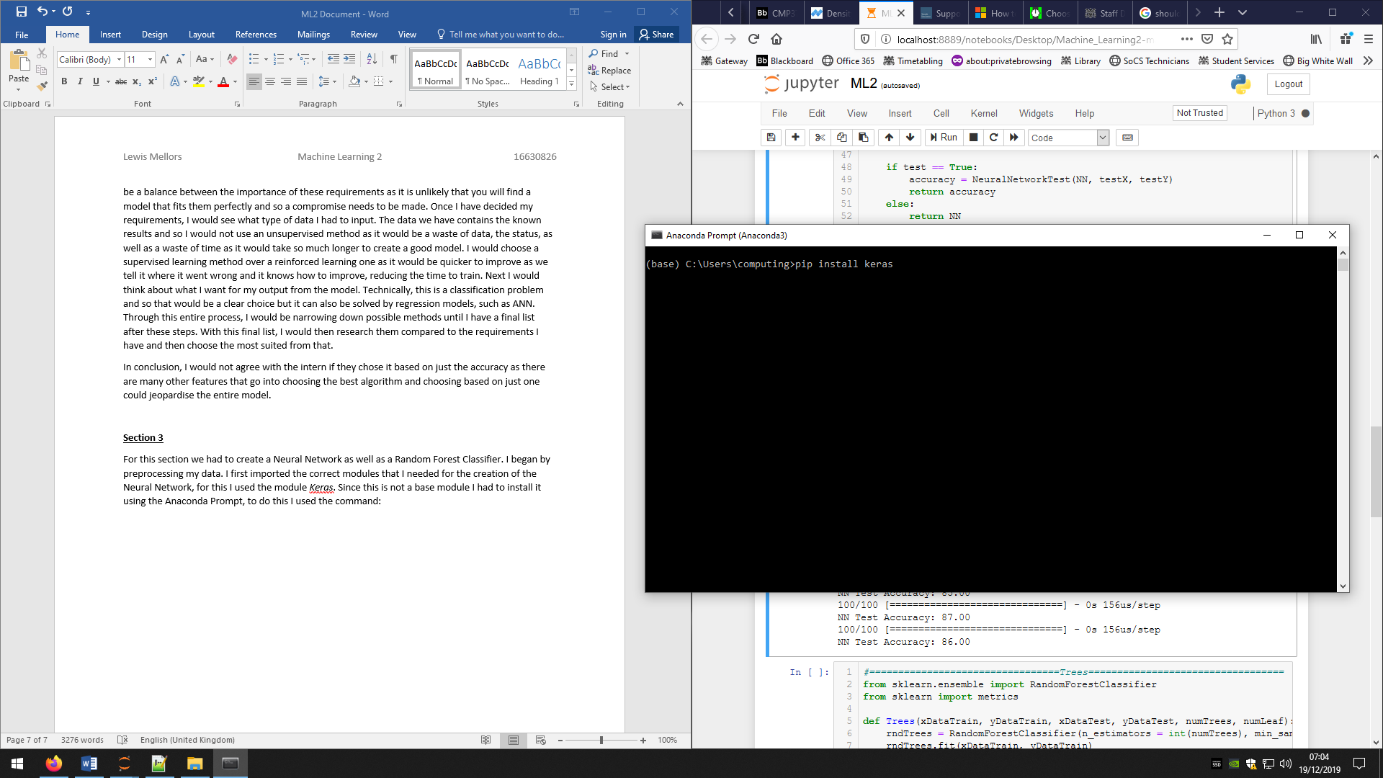

*Figure (15) Figure (16)*

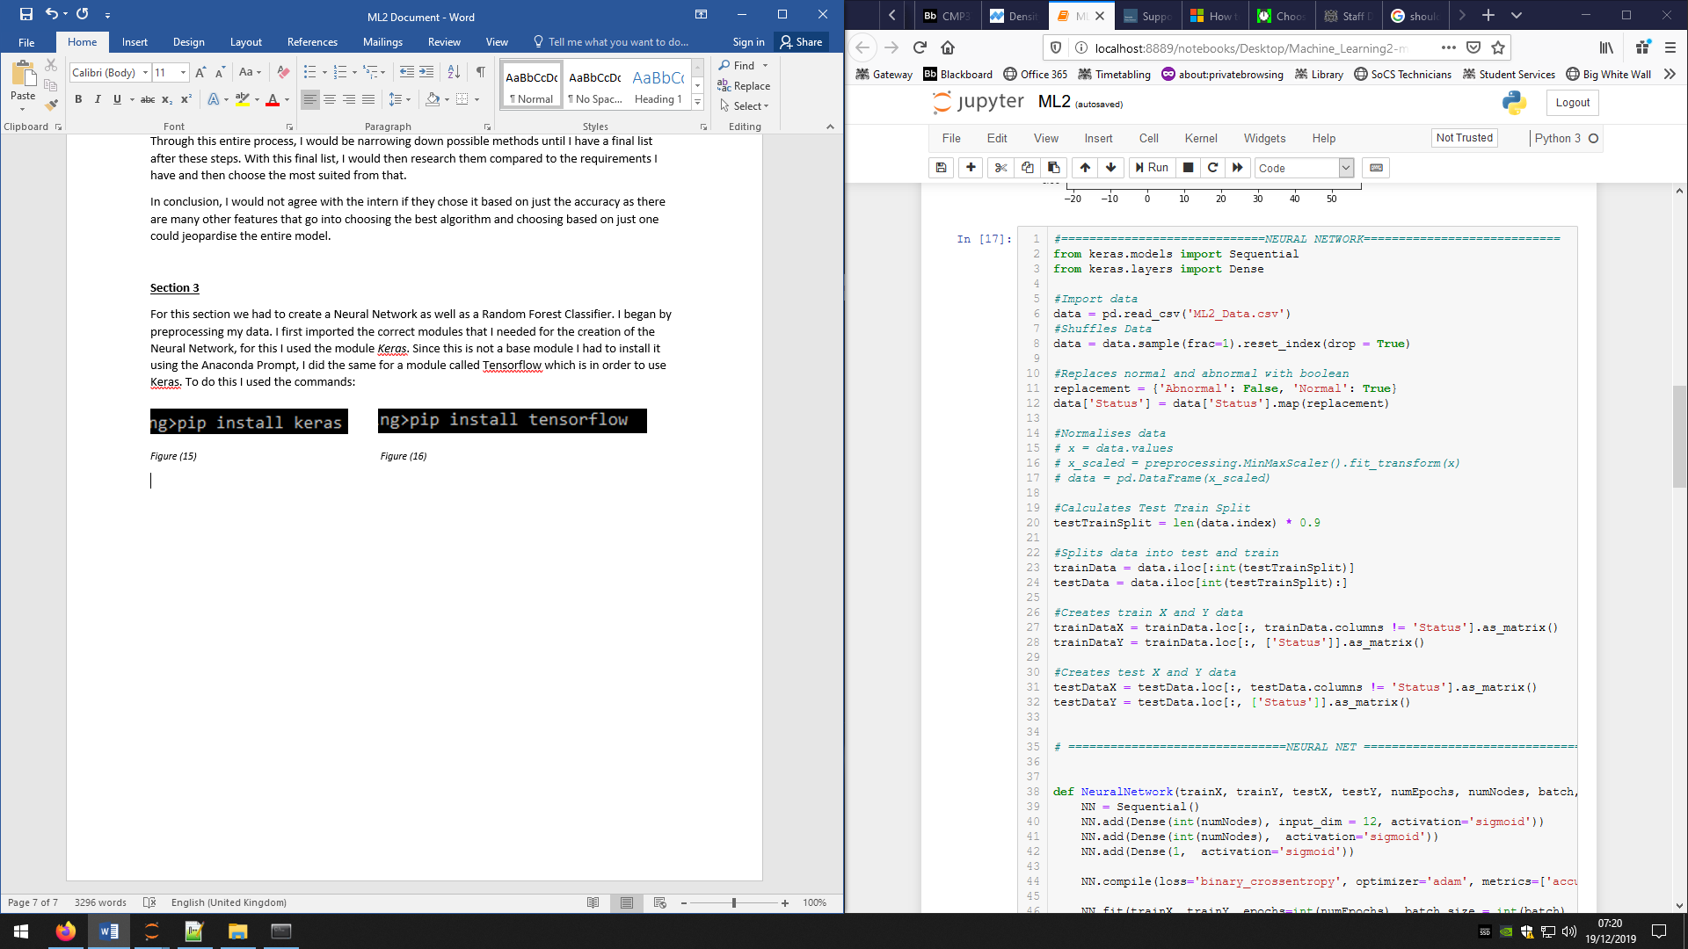

*Figure (17)* Figure(17) shows importing the keras modules.

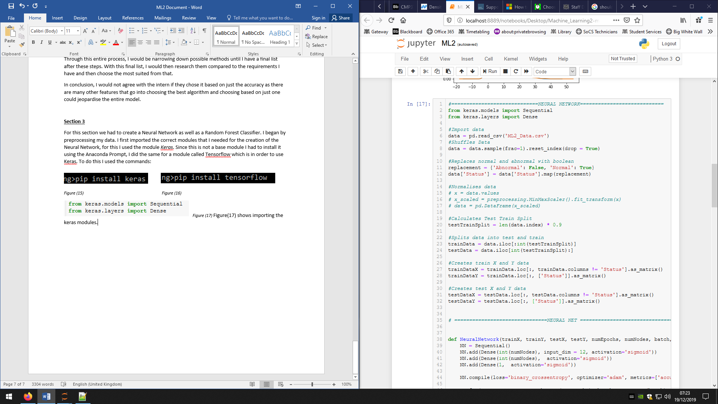

*Figure (18)*

The above figure (18) I have reimported my data and shuffled it, this meant the data when split does not contain just normal or just abnormal data. I then use the *map()* command to replace all the strings *‘Normal’* and *‘Abnormal’* with binary 1 or 0 respectively, I did this so the models could directly compare the results without me having to convert them to strings and then create if statements to compare.

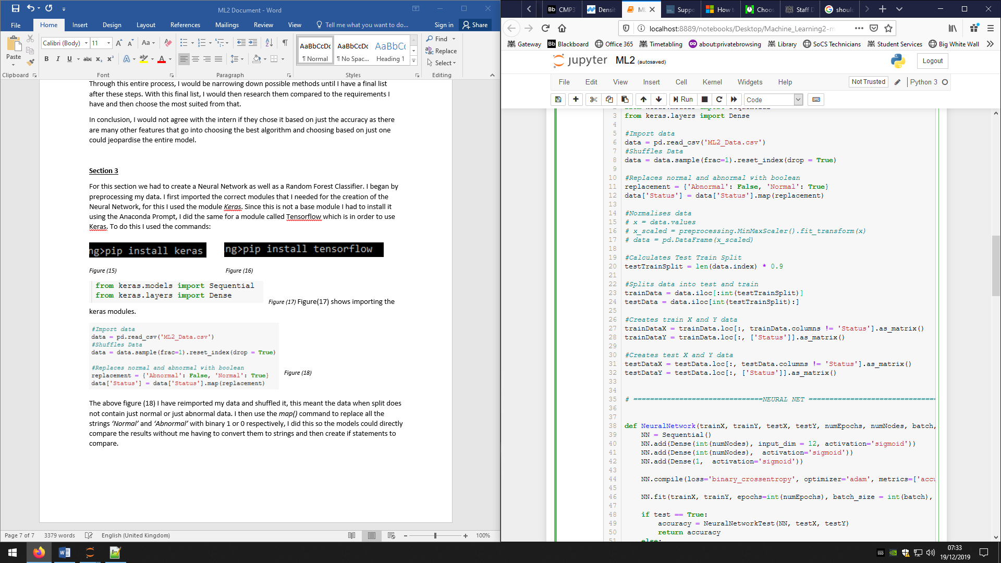*Figure (19)*

I originally normalised my data as during my research I found that it was suggested to normalise data when using neural networks. However, after testing my Neural Network I found that I was getting better results when I did not normalise the data. If I want to normalise the data I would use the code in Figure (19), where data is my entire data set.

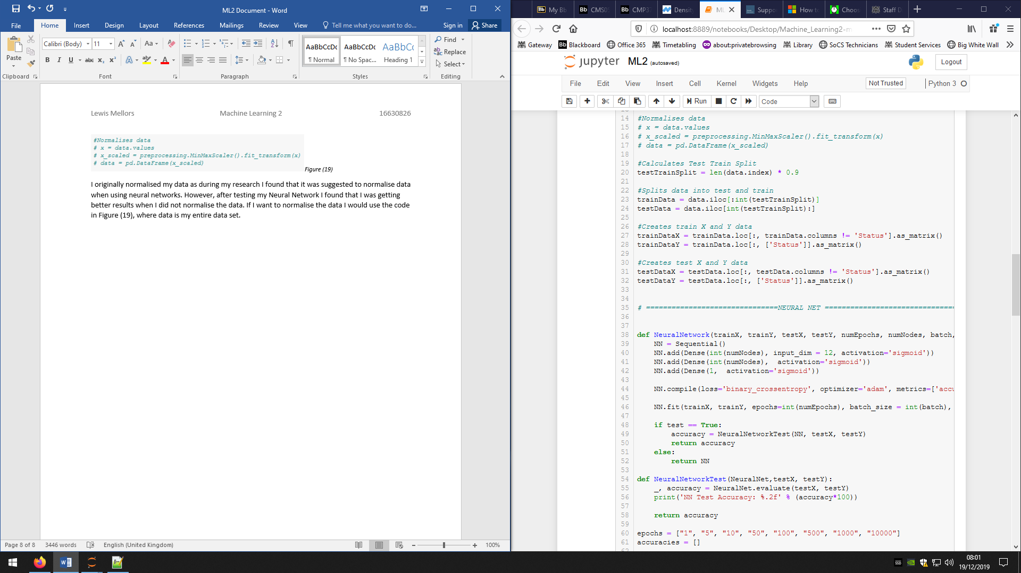

*Figure (20)*

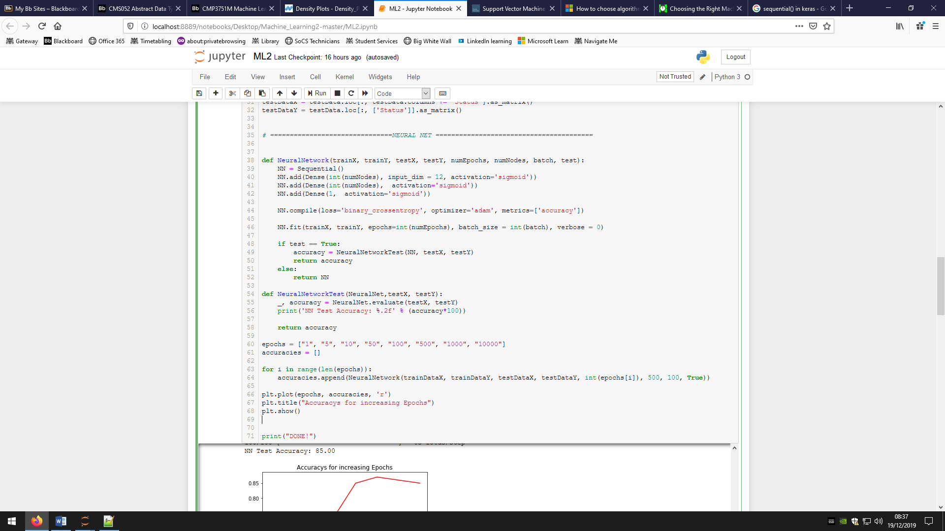Figure (20) shows how I split the full data set into test and train data as well as creating the X and Y sets for each. I begin by creating a variable to store how much data is in 90% of the total data (which come to 896), I then use this to create the test and train data frames using the *iloc[]* command which splits the data horizontally. The next set of statements splits the test and train data sets into their X and Y data sets. To do this I use the *loc[]* command which lets you specify the exact data you want, I used it to keep all the rows of the data but split only the first column which is the *‘Status’* to create the *Y* data. We do the same but make sure we keep all but the first column to create the *X* data.

*Figure (21)*

I made creating a NN a function as it makes it easier to automate later on, I pass over the X test and train data, the Y test and train data, the number of epochs, the number of nodes per hidden layer, the batch size, and a Boolean to know if they want it to be tested or not. The number of epochs is the number of times the data set will be run through the model, the general rule is the higher the epochs the more accurate the final model is as it has had more time to train. The batch size is the amount of data that will be passed through the model until it recalculates the weights, the general rule is the lower the batch size the more accurate it is up to a certain point.

The first line inside the function creates a variable that is defined to become a model. The next three lines add the NNs layers onto the model. The first line creates the first hidden layer with the specified number of nodes and defines how many inputs are going to be given to it, in our case the 12 features. It also specifies the activation function of the nodes to be the sigmoid function, this function produces a number between 0 and 1. The second line creates the second hidden layer with the sigmoid again but does not need to specify the inputs as we already have another layer. The final line creates the output layer with one node and the sigmoid function once again. The sigmoid function is a logistic function.]

The compile command finally turns the model into an official NN. The *‘binary_crossentropy’* states that we are using the binary cross entropy which is a loss function which specifically handles outputs that are between 0 and 1. For an optimiser we chose *‘Adam’* which is an extension of the stochastic gradient decent, Adam uses adaptive learning rates meaning it chooses what learning rate to use based on the other parameters. The metrics is what you want the NN to create to measure how good it is, in our case we want the accuracy.

We can finally train our NN using the *fit()* command. We pass it the training data as well as the number of epochs we want, and the batch size. The final command means it does not print an animated loading bar which is an aesthetic feature of Keras. The command does what is stated in section 2 but uses matrices to make it more efficient. All the data and weights are stored in matrices that can be dot product together to create all values for all the nodes in a layer at once.

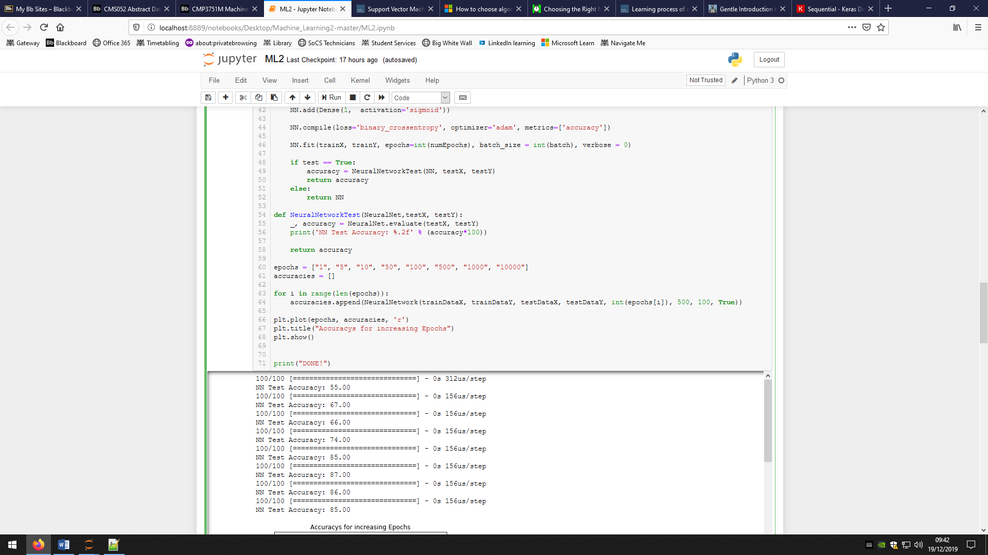After that, the created and trained NN and test data is passed to a separate function that uses the *evaluate()* command that runs the test data through the NN and calculates an accuracy for that data set for that NN.

*Figure (22)*

The above figure shows the accuracy function stated in the above paragraph. For the bonus task, you have to compare the accuracy of different number of epochs and so I created a list that holds all the number of epochs I want to test. I then create an empty list that I will use to store the accuracies of the different epoch NNs. I then loop through the epoch list and call the Neural Network function with the same parameters except changing the number of epochs each time. I had to use 500 nodes per hidden layer but I decided to use a batch size of 100 as it gave a good balance between runtime and increased accuracy. Finally, I plotted the epoch number against the accuracy to clearly show the pattern.

The results are as shown:

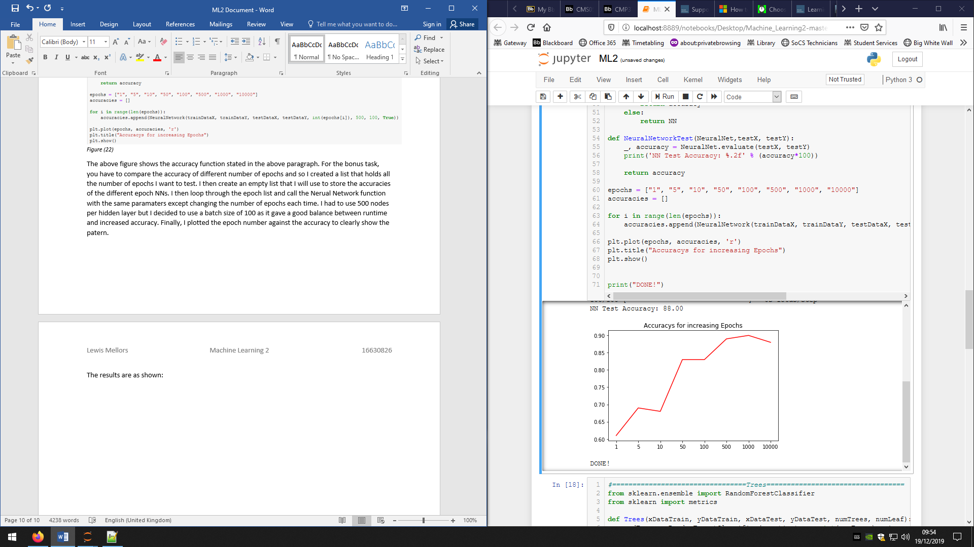

*Figure (23)*

Figure (23) shows the number of epochs on the X axis and the accuracy on the Y axis. The trend of the data shows that the higher the number of epochs the higher the accuracy, however, since the data is shuffled and the beginning weights are randomised every time I run the code, it means this trend can have varying gradients as well as varying point to point values. For example, the 1th epoch’s accuracy is lower than the 5th epoch’s accuracy but this is not always the case and for the majority of the time it is actually higher. This graph also shows that the change in accuracies between 500 and 1000 epochs is not that much and so the maximum accuracy is beginning to be reached for these sets of parameters.

The second part of the third section was to create a random forest classifier (RFC). An RFC works using decision trees that each decide what the predicted outcome should be and then the outcome with the most ‘votes’ becomes the official outcome. If the tree was right then it does not change anything, but if it voted wrong then it adapts it parameters to compensate for this fault. There are 2 factors that we can customise in out RFC, the number of trees in the forest, and the minimum samples in a leaf for it to consider splitting into a deeper layer. This means that the trees do not have a set depth and instead the depth is dynamically changing based on the min samples leaf and the size of the data subset that that tree is using. Generally, the more trees in the forest the higher the accuracy as there are more trees that are independently deciding on the outcome. This is opposite in the case of the min samples leaf as the lower the minimum samples, the higher the accuracy as the data is split down into smaller groups and the data is ‘analysed’ more thoroughly. When teaching the RFC, the trees take samples of the data which is draw with replacement meaning the data is not removed when chosen and so can be used multiple times for a single tree.

I began by importing the Sklearn modules I would use:

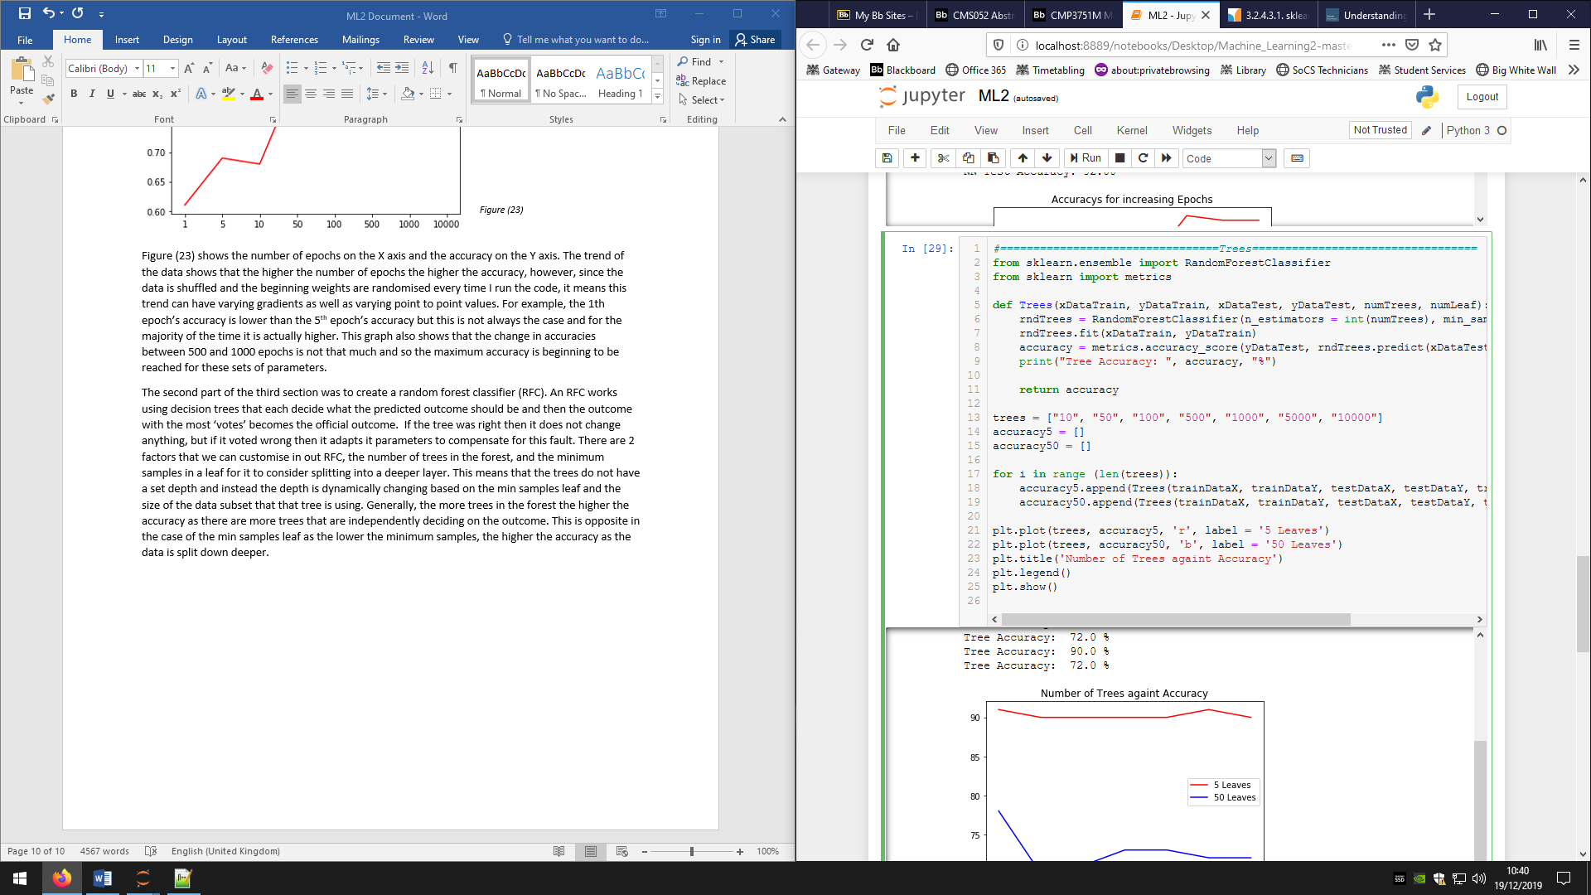

*Figure (24)*

Since I was using the same test and train data as the NN I did not need to do any preprocessing.

I created another function to create the RFC as, again, this will make it easier later on when I have to call it many times. I pass over the test and train data for X and Y as well as the number of trees I want for that model and the minimum number of samples for a leaf split.

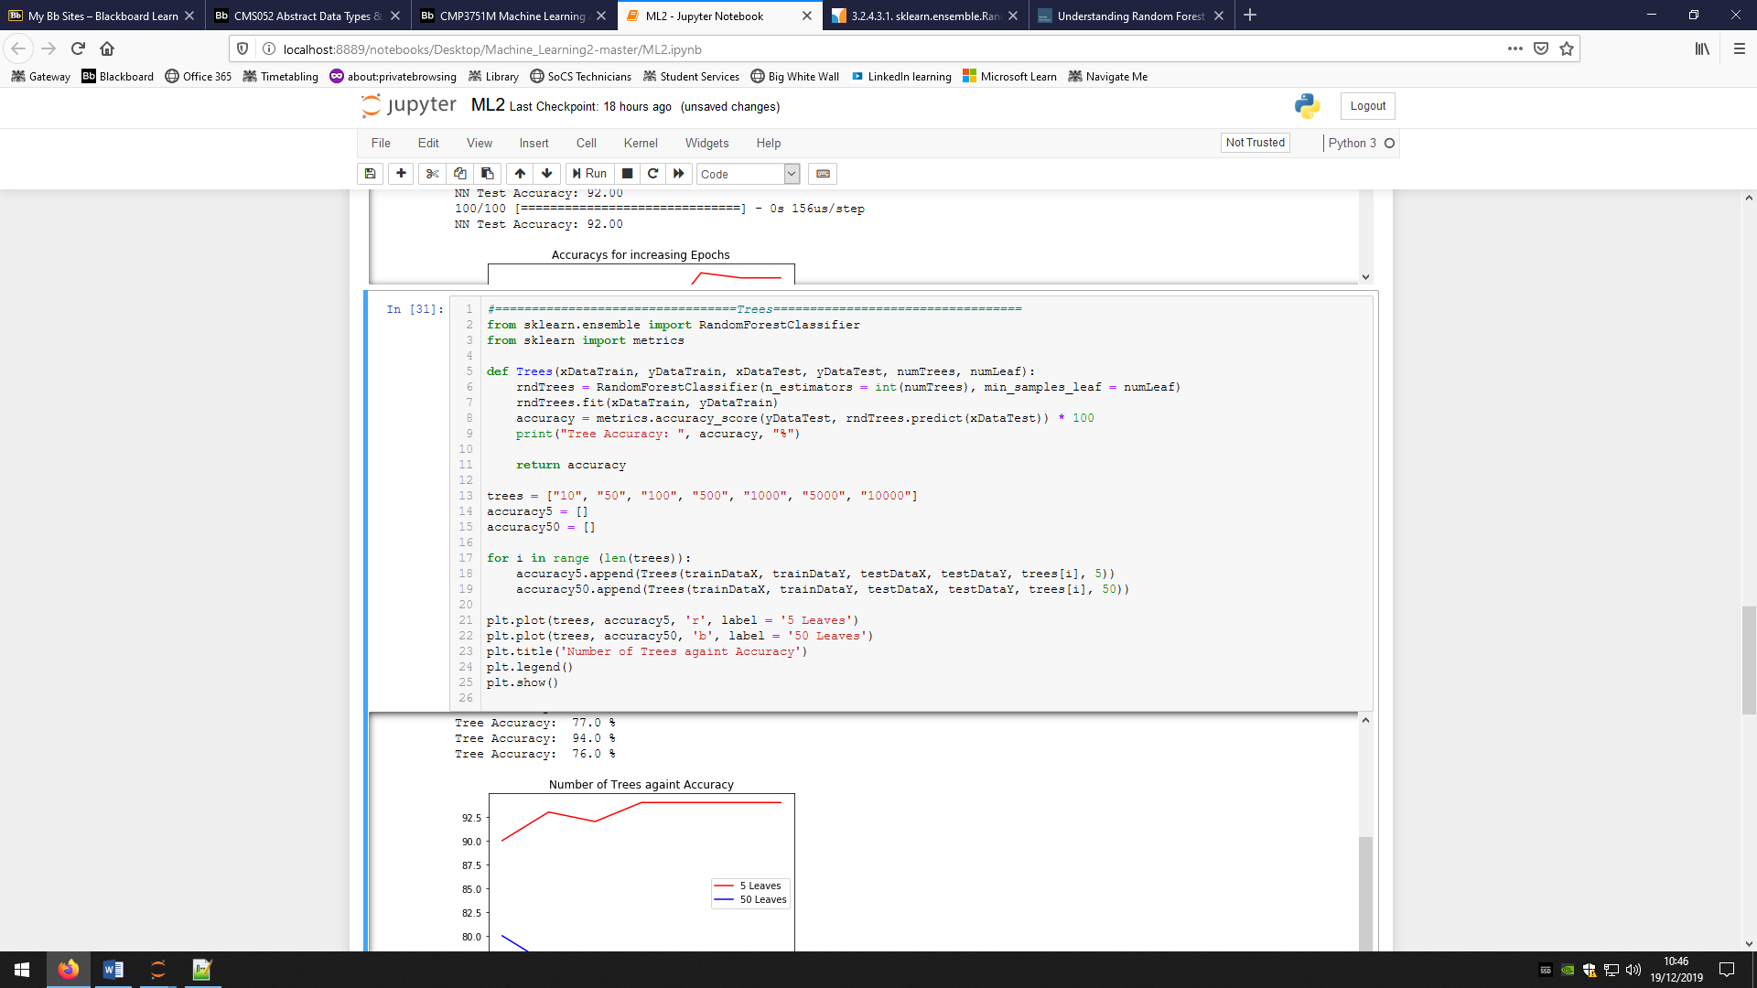*Figure (25)*

The function begins by creating a variable that is just the basic model with the specified parameters we want. We then use the *fit()* command to train the model using the training X and Y data. An accuracy for the test data is then made by using the *metrics.accuracy_score* which takes 2 parameters of the actual Y data and the predicted Y data. That we get from using the *predict()* command again and inputting the X test data. This accuracy is then printed.

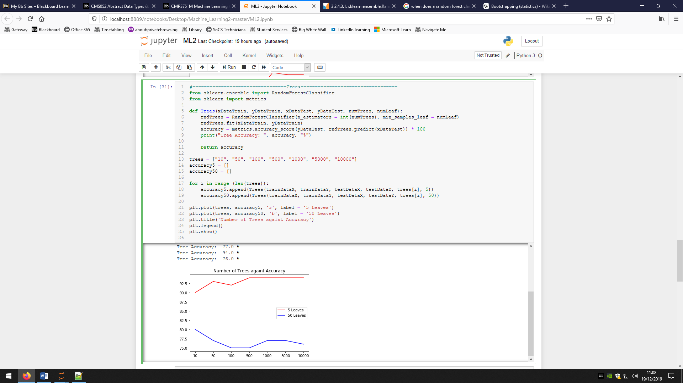

*Figure (26)*

The above figure is very similar to the NN one however we were tasked with also analysing how changing the min_samples_leaf can affect the efficiency. Again I create a list containing all the number of trees I want to test, but this time I create two empty lists that will hold the accuracies for the 5 and 50 min_samples_leaf variables. I loop through the list of number of trees and add the accuracies of the RFC models created by the specific parameters to their respective lists. I then plot the two lists against the number of trees on the same graph using *plt.plot().*

These are the results:

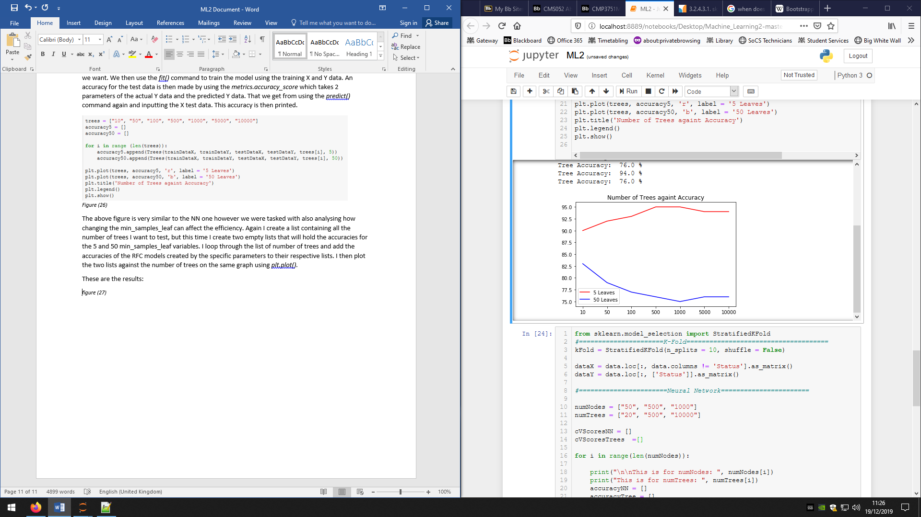*figure (27)*

As you can clearly see, the all variation of tree numbers accuracy is better with a minimum sample leaf of 5 than 10, this is a predicted outcome. Something that was not predicted was that increasing the number of trees for the 50 leaves models creates a negative accuracy gradient, this should be the opposite in theory. Since the untrained model is different every time, I ran the model several times to see if this was an anomaly but almost every time this trend appeared. Therefore, my data shows that for 50 leaves, the lower number of trees produces a higher accuracy. I can conclude though that for 5 leaves, the more trees the model has, the higher the accuracy. However, accuracies peak at between 100 and 500 trees over my multiple runs.

**Section 4**

For the final section of the assignment, we were tasked with finding the optimal parameters for the the number of nodes in the hidden layer of the NN and the number of trees in the RFC from a select few. To do this we used 10-fold Cross validation, which is where the entire data set is split into 10 ‘folds’ of data, each with their own test and train splits and then use this to get average accuracies.

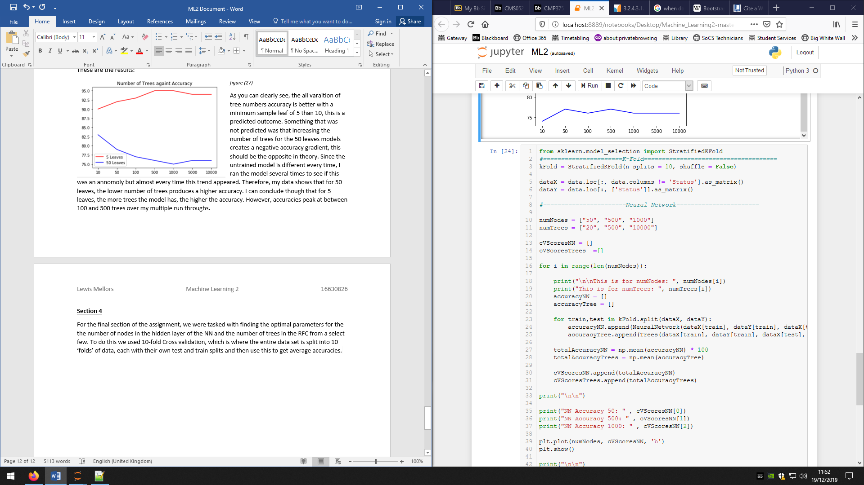

*Figure (28)*

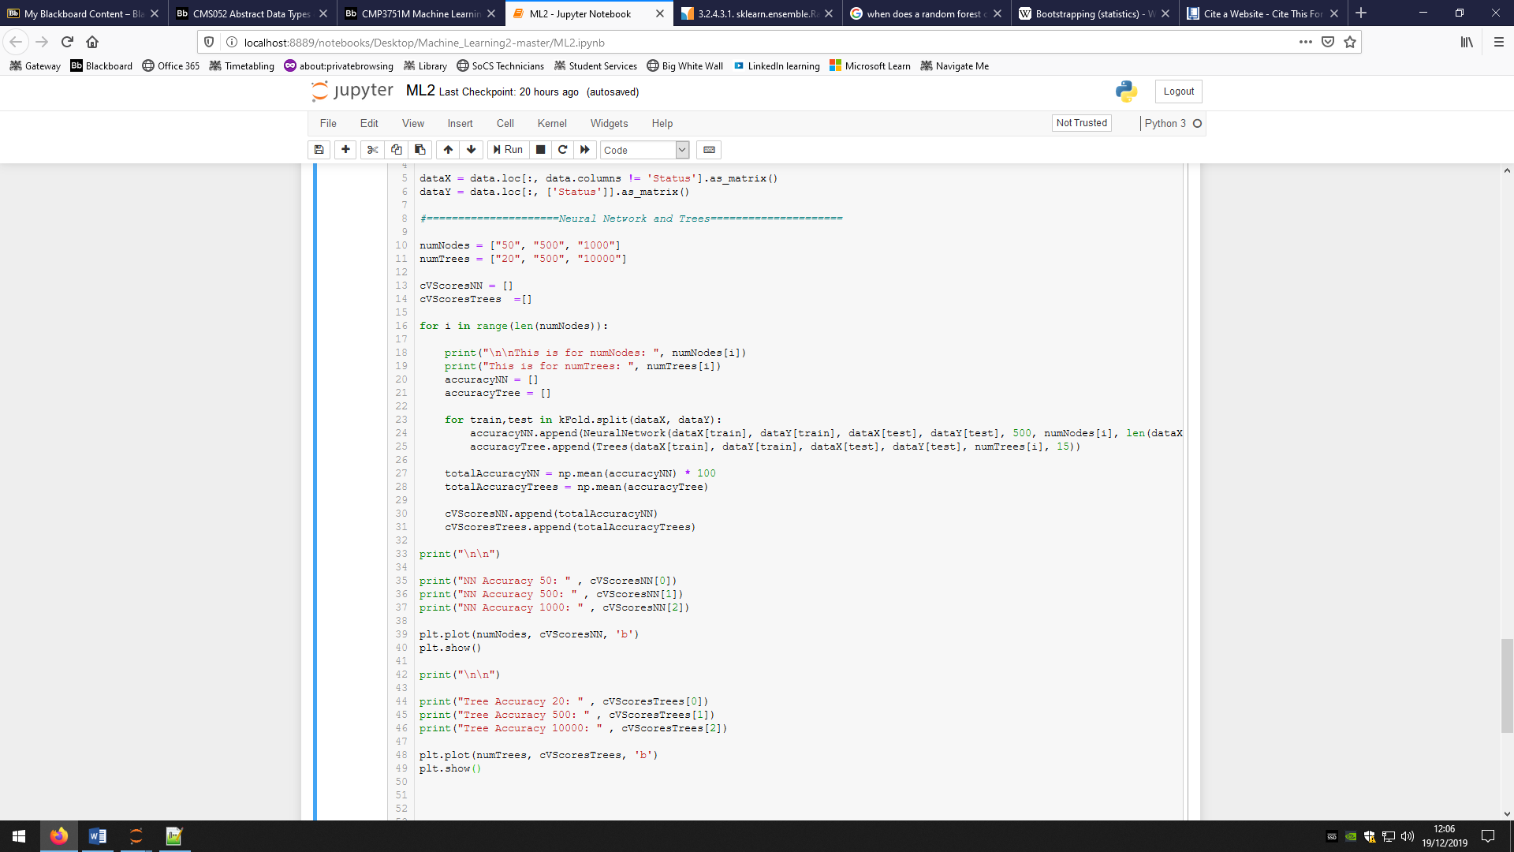I began by importing the *StratifiedKFold* module from *Sklearn.model_selection.* This is what I was going to use to split my data instead of doing it manually and having a lot of lists (40 in total). I used this module to create a variable to hold the Kfold preferences that I want, split the data into 10 and do not shuffle the data. I then made sure I had the full data set of X and Y by creating the variables again from the full data set.

*Figure (29)*

I begin by setting out lists that hold the parameter variables that I’m going to change for each of the NN and RFC. Two more lists are made but they are empty and will be used to hold the cross-validation accuracies. I then loop through the 2 parameter lists and print references for when the code runs and prints a lot of values. Two temporary lists are created that will hold the 10 accuracies created but the 10 folds for each model. Another loop is made where the X and Y data is officially split into 10 individual sets. This loop then loops through those 10 sets, meaning iteration of the loop has new X and Y train and test data sets. I then use the parameters and call the NN and RFC functions to create and test the models and then store their accuracies. The other parameters for both models are never changed and the values I chose I believe to be a good balance between speed and accuracy. I then get the mean of the 10 accuracies for that parameter variable for both NN and RFC giving me an average accuracy.

We use Kfold as getting the average of a set of results gives you a more reliable result that better represents the model and proves that the model can reliably work constantly.

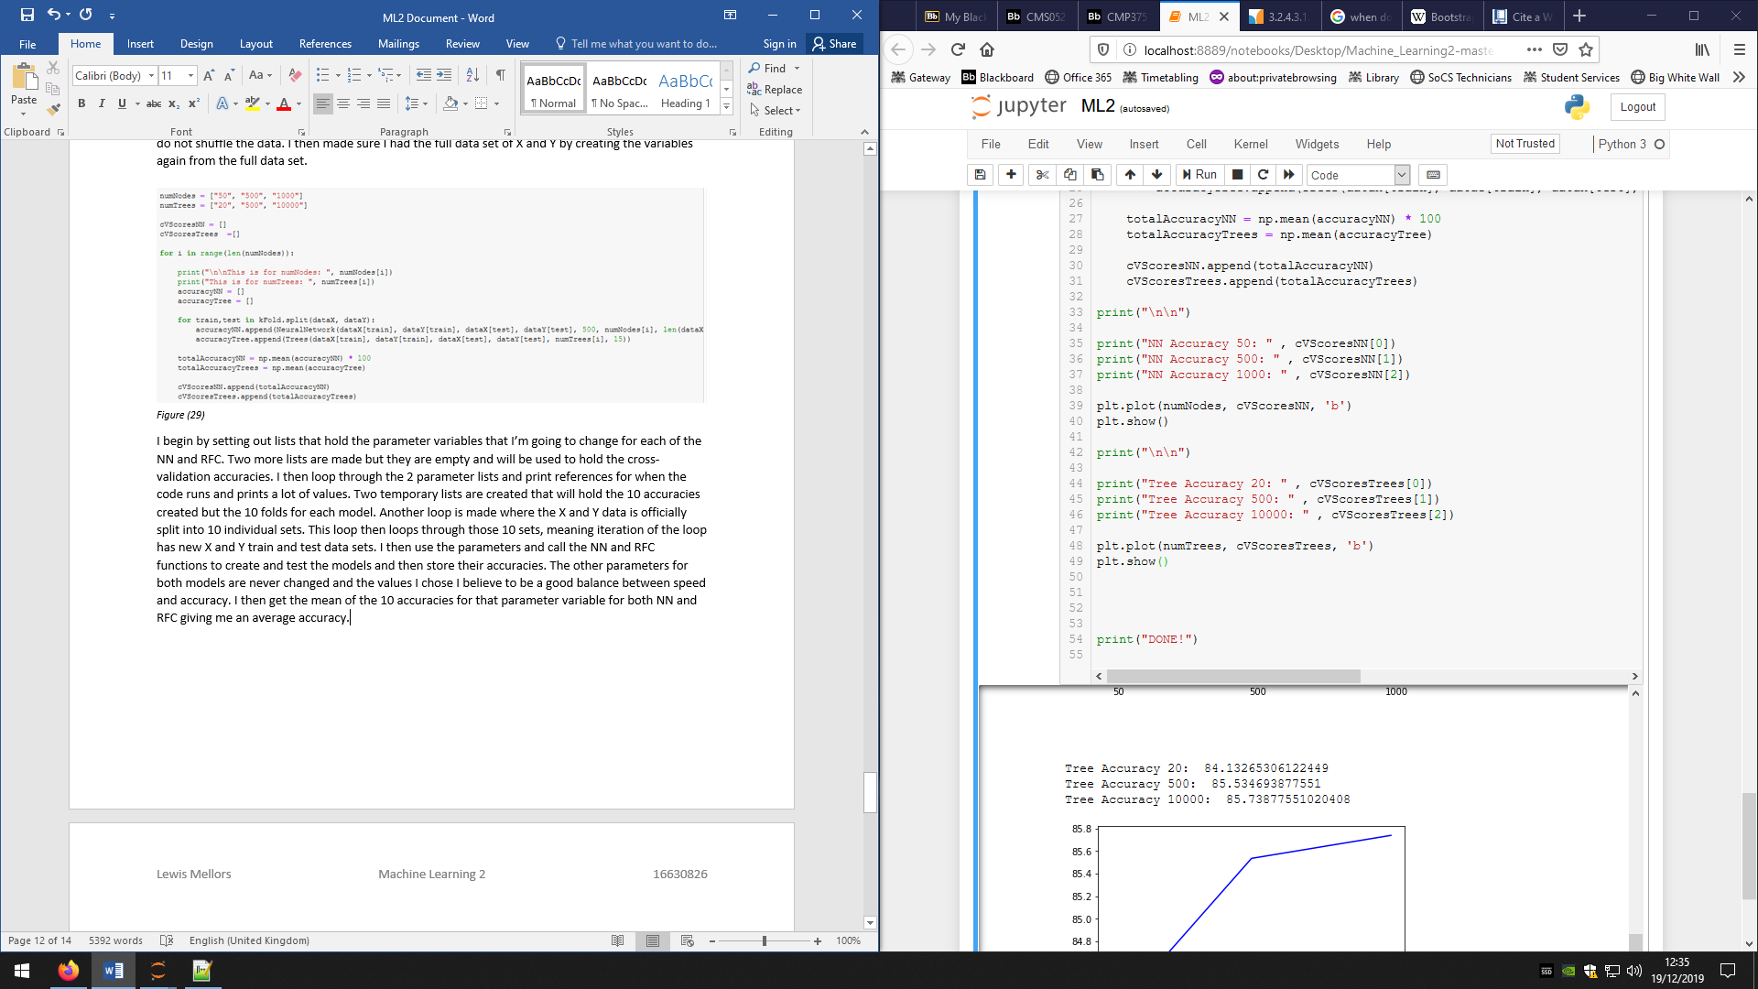*Figure (30)*

Figure (30) shows that I print out the accuracies as well as plot them on graphs, giving the following results:

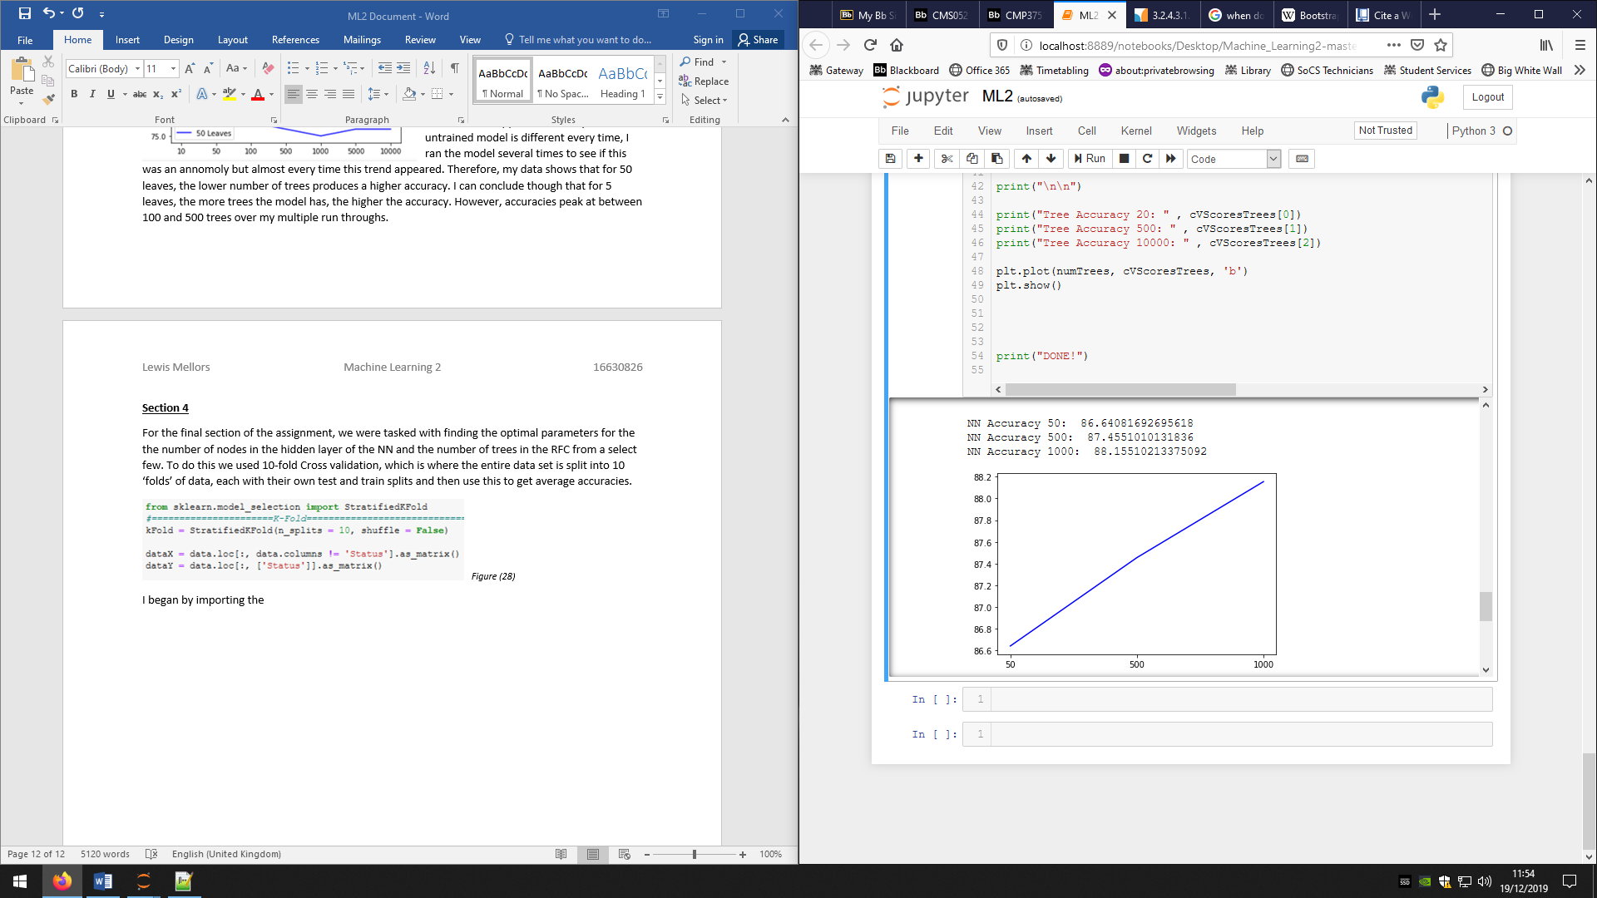*Figure (31)*

Figure (31) shows the results for the different number of nodes for the NN. It shows a positive gradient meaning the accuracy increases as the number of nodes increases. However, this increase is very small, only ~1% when changing between the numbers of nodes. Since the time taken to train a 1000 node NN compared to a 50 node NN is drastically higher, the question of which is better becomes harder as you have to think about the importance of how quick the model needs to train compared with an increase of just 2%. In our situation, where we do not have a time limit for model training, I would choose 1000 nodes as even though it took a long time to train, it did yield the highest accuracy which is a major part of our requirements.

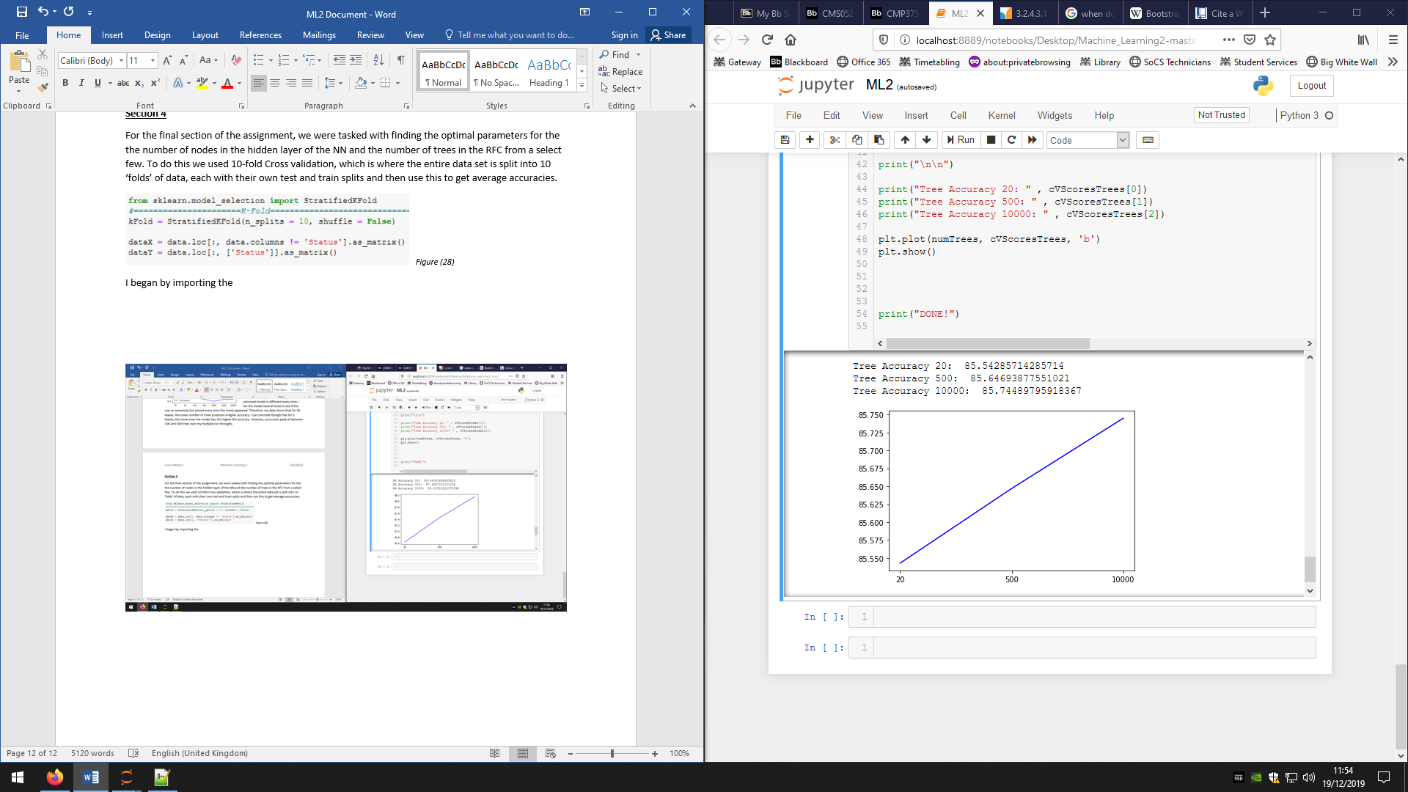*Figure (32)*

Figure (32) shows the results for the different number of trees in a RFC. These results also show a positive gradient meaning the more trees you have the higher the accuracies, this contradicts what was shown in the previous section where the accuracy peaked 1000 trees and then began to decrease. However, I trust these results more as they are tested 10 times the amount than in section 3 and so these are more reliable results. The increase in accuracy between each set of trees is even less than the NN with an increase of ~0.1% each time making very little difference, 1 in 1000. Depending on how often data is needed to be predicted this could cause very little change or a much bigger change. For example, if data is given every day, then there would be a difference of 1 reading in 2.7 years, but if the data is given every second then a difference would be 1 in every 16.6 minutes. Since, again, we have no limit on training time, I would still choose the 10000 trees as even though it is a small increase in accuracy, it will add up over a long period of time.

In conclusion, throughout this report I have analysed our data set, discussed how I would choose a model, and analysed how changing some parameters can cause the accuracy to change with and without 10-fold. This scenario could very easily work with both models as both can handle large data sets and large amounts of features, there is nothing abnormal about the data that could cause problems. Overall the models are almost completely matched. However, with all this information and data I have gathered from my results of the assignment tasks, I have decided that the best model would be an Artificial Neural Network. I have mainly chosen this model as it fits the requirements well and my tests show that I can achieve the highest accuracies out of the two. I have also chosen this as compared to a Random Forest Classifier as I believe with manipulating the parameters I would be able to get a higher result with an ANN. This is because the accuracy trend seems to plateau around 90 where as I have yet to find the ANN consistently plateau at a value meaning I believe I could hit higher accuracies. The RFC does have a quicker train time but it is not by much and as previously stated, train time is not an issue for us. However, these conclusions have been made with only the limited research I have done and my statements could be true for my unique case but not for others, for a complete, fully justified answer I would have to do more extensive research.

**References:**

Jaitley, U. (2018). *Why Data Normalization is necessary for Machine Learning models*. [online] Medium. Available at: https://medium.com/@urvashilluniya/why-data-normalization-is-necessary-for-machine-learning-models-681b65a05029 [Accessed 13 Dec. 2019].

Brownlee, J. (2017). *What is the Difference Between Test and Validation Datasets?*. [online] Machine Learning Mastery. Available at: https://machinelearningmastery.com/difference-test-validation-datasets/ [Accessed 13 Dec. 2019].

Patel, S. (2017). *Chapter 2 : SVM (Support Vector Machine) — Theory*. [online] Medium. Available at: https://medium.com/machine-learning-101/chapter-2-svm-support-vector-machine-theory-f0812effc72 [Accessed 13 Dec. 2019].

Gandhi, R. (2018). *Support Vector Machine — Introduction to Machine Learning Algorithms*. [online] Medium. Available at: https://towardsdatascience.com/support-vector-machine-introduction-to-machine-learning-algorithms-934a444fca47 [Accessed 14 Dec. 2019].

Docs.microsoft.com. (2019). *How to choose algorithms - ML Studio (classic) - Azure*. [online] Available at: https://docs.microsoft.com/en-us/azure/machine-learning/studio/algorithm-choice [Accessed 14 Dec. 2019].

Harlalka, R. (2018). *Choosing the Right Machine Learning Algorithm*. [online] Hackernoon.com. Available at: https://hackernoon.com/choosing-the-right-machine-learning-algorithm-68126944ce1f [Accessed 14 Dec. 2019].

Torres, J. (2018). *Learning process of a neural network*. [online] Medium. Available at: https://towardsdatascience.com/how-do-artificial-neural-networks-learn-773e46399fc7 [Accessed 14 Dec. 2019].

Keras.io. (n.d.). *Sequential - Keras Documentation*. [online] Available at: https://keras.io/models/sequential/ [Accessed 15 Dec. 2019].

Brownlee, J. (2019). *Gentle Introduction to the Adam Optimization Algorithm for Deep Learning*. [online] Machine Learning Mastery. Available at: https://machinelearningmastery.com/adam-optimization-algorithm-for-deep-learning/ [Accessed 15 Dec. 2019].

Yui, T. (2012). *Understanding Random Forest*. [online] Medium. Available at: https://towardsdatascience.com/understanding-random-forest-58381e0602d2 [Accessed 16 Dec. 2019].

Brownlee, J. (2019). *A Gentle Introduction to k-fold Cross-Validation*. [online] Machine Learning Mastery. Available at: https://machinelearningmastery.com/k-fold-cross-validation/ [Accessed 16 Dec. 2019].

3Blue1Brown (2017). *What is backpropagation really doing? | Deep learning, chapter 3*. [video] Available at: https://www.youtube.com/watch?v=Ilg3gGewQ5U [Accessed 16 Dec. 2019].